**Object Oriented development and testing report**

**By Joseph Batchelor**

**GitHub repository:** https://github.com/JosephBatchelor/2020-CI553-catshop.git

**\***note the repository is set to private and I am unable to alter this because it has been forked.

**Planning section**

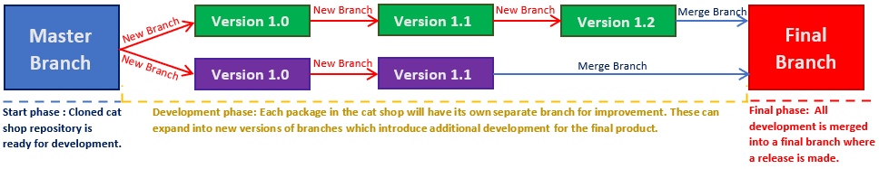My initial plan is to individually work on different clients in separate branches. These branches will expand from the master branch introducing different functionality and design. Once all the necessary development is done, I will merge each branch into a final version which implements all the changes made in one branch & release. Below is an image to help visualise the development plan.

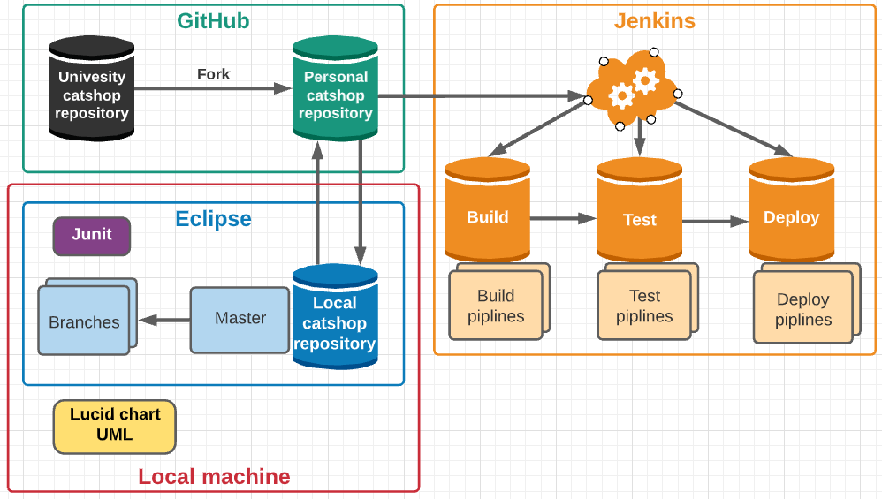**Project structure setup**

This is the project structure which I will be using throughout my development.

**Pull**

GitHub will be my link between Eclipse and Jenkins for continuous integration. As my code will be pushed and organised within my Git repository.

**Push**

Lucid chart application will be on my local machine as well as eclipse.

\\

**Basic Installation & tutorial**

Below will be a list of tools that I will be introducing within my project. Additionally, I will demonstrate a basic set up for each one as well as any necessary actions that will be needed through the development of catshop.

**Junit Installation & tutorial**

**Junit:** Will be used to test different areas of developed code to test that their functionality works correctly or as expected (This is already integrated within the eclipse IDE) . Creating a junit test case is simple and can be seen below.

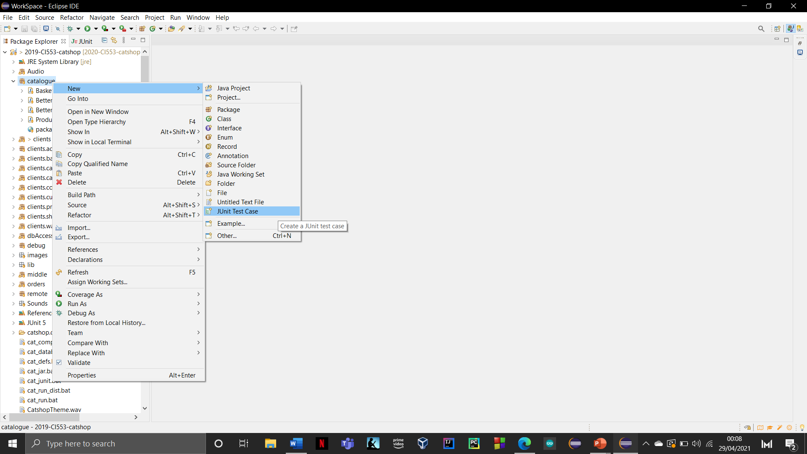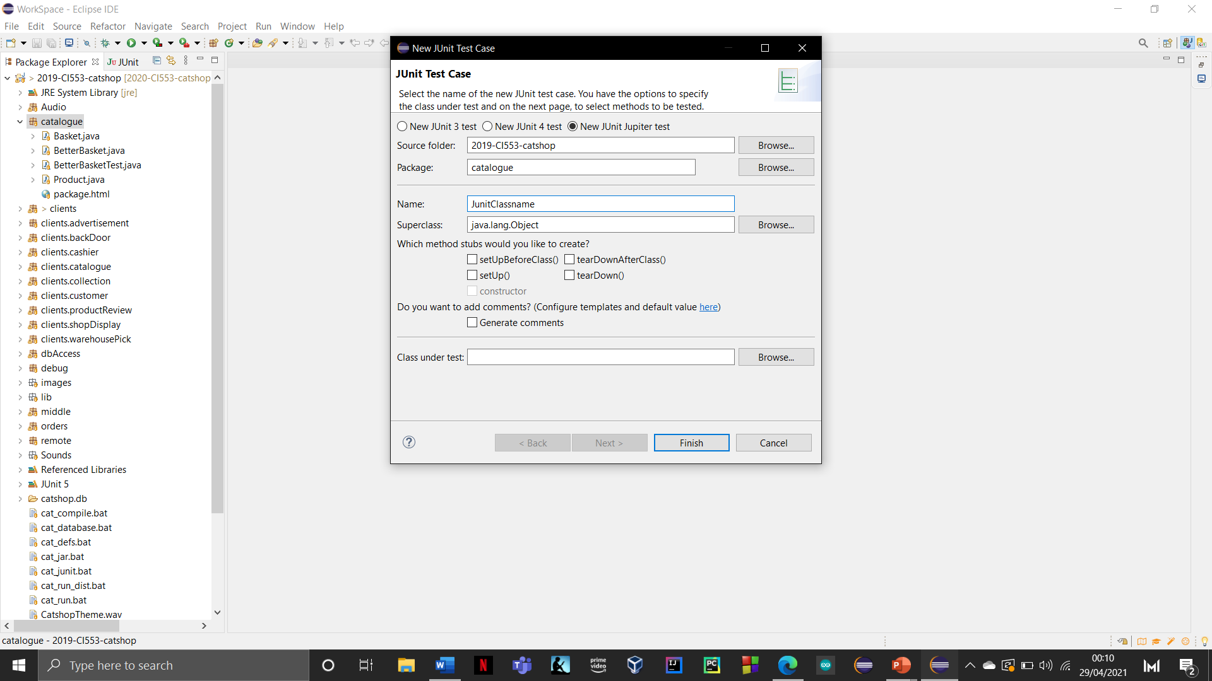

**Jenkins Installation & tutorial**

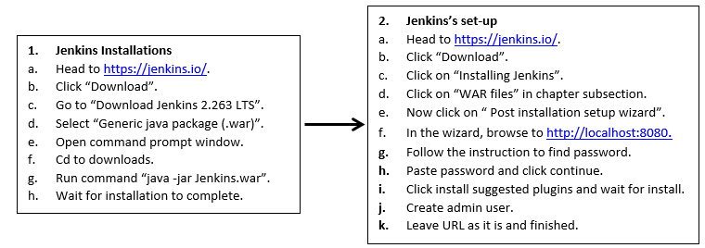**Jenkins’s:** This will be used for continuous integration of catshop. It helps with Junit testing and deployment of different areas of development. This will also determine if branches of development are ready for public release as well as if development tasks were successful.

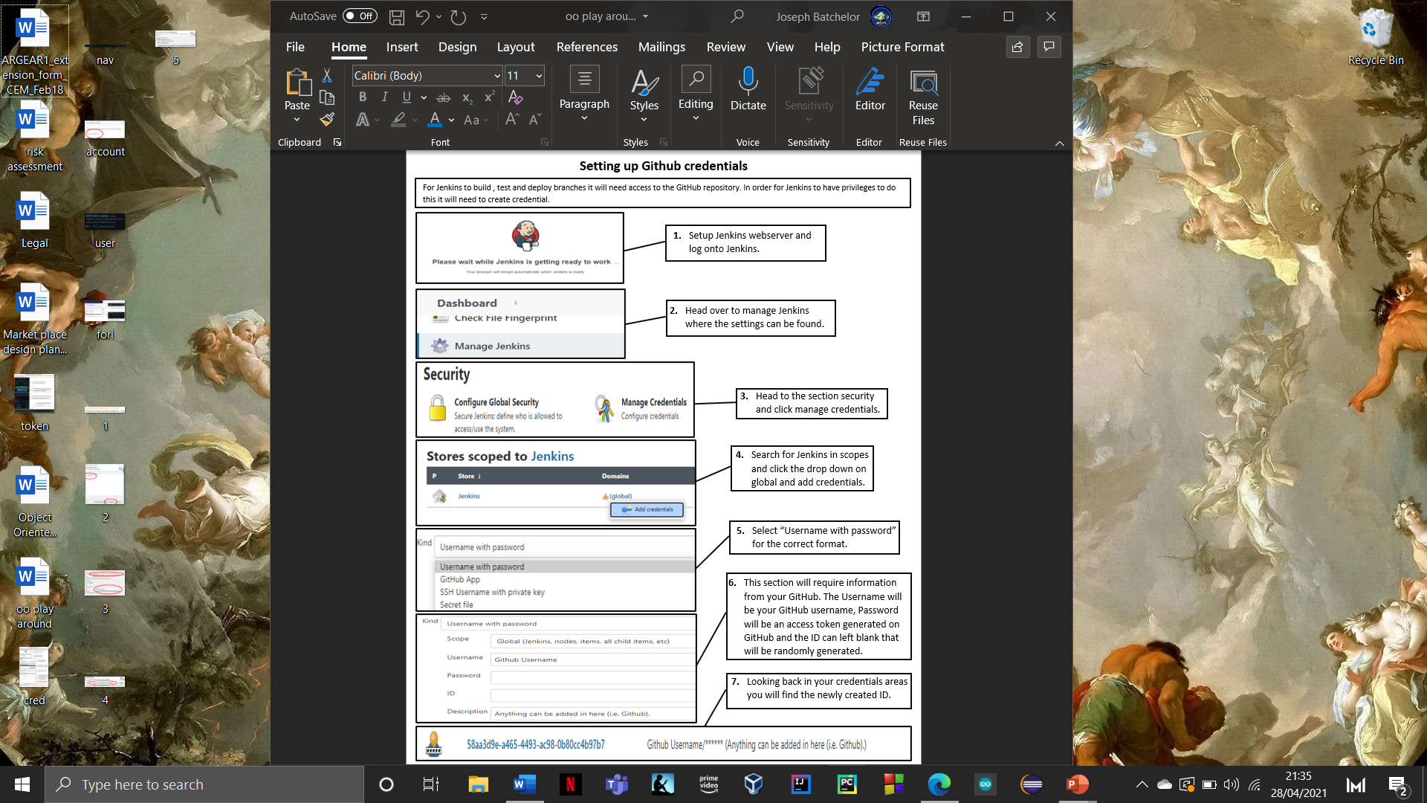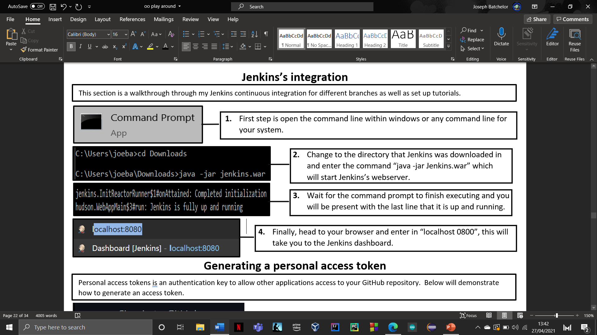

**Setting up Jenkins virtual server**

**GitHub Installation & tutorial**

**GitHub:** This will house all the development of cat shop as well as allow me to correctly organise each development into separate branches. Additionally, it will be used to create different releases which display previous development builds and progression. For management during development, GitHub will provide the necessary tools for adequate documentation. This means when committing comments will be time stamped and dated and contain a brief description of what changes were made. This will allow for sufficient organisation.

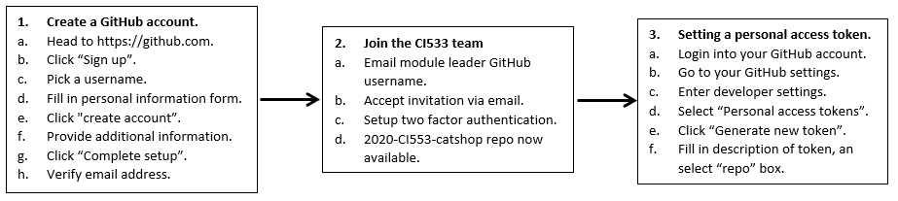

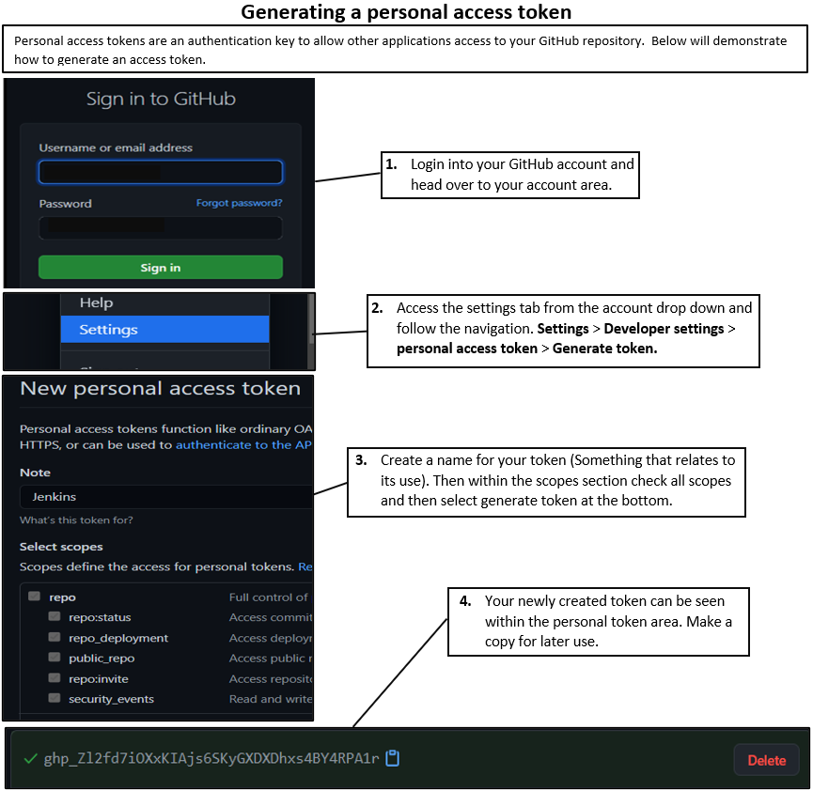

**UML Installation & tutorial**

**UML :** This will allow me to better explain and visualise different scenarios with the use of diagrams. Instead of using White star I will be using lucid chart which is a free application that integrates diagram software like uml.

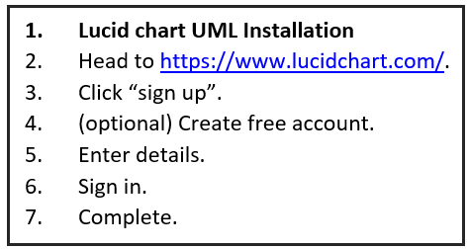

**How to create UML diagram’s**

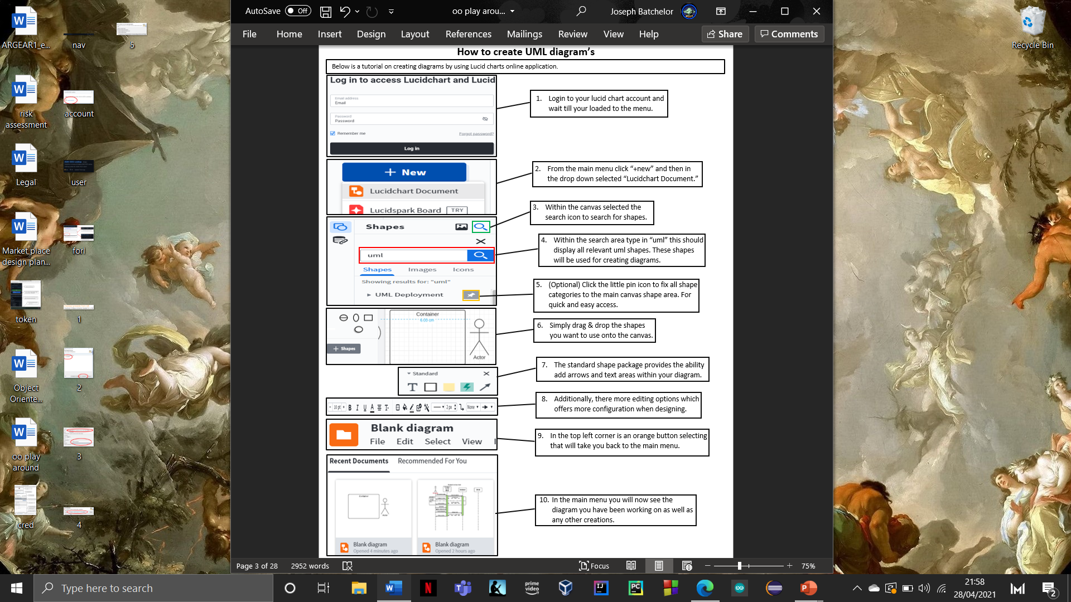

**Forking Catshop repository on GitHub**

In order to work on catshop we need to have our own version of it. To do this we will need to fork it from the university account.

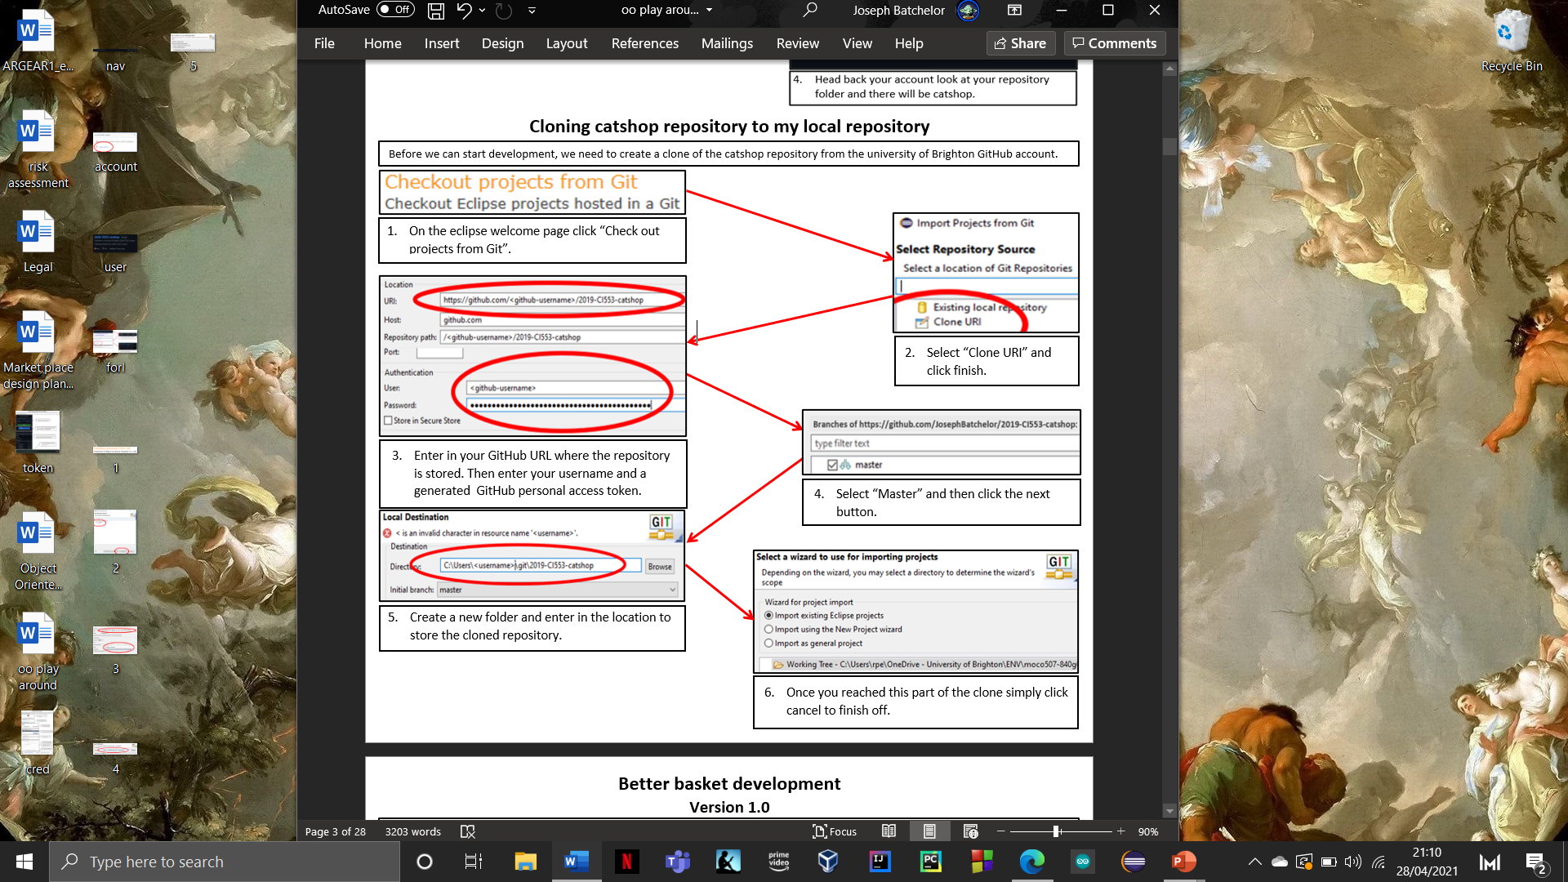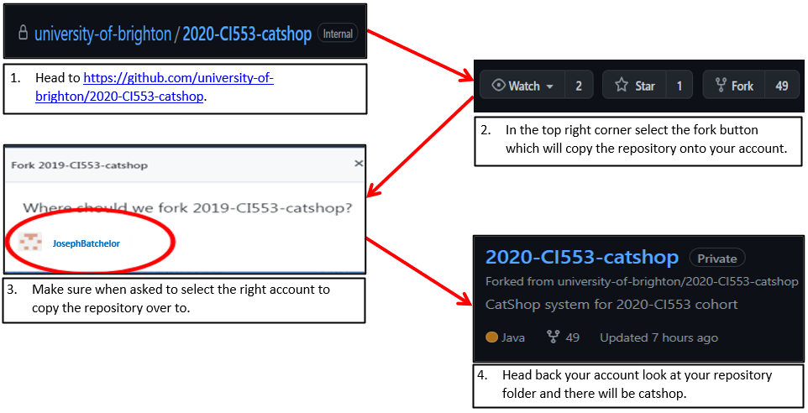

**Development section**

**Better basket development**

**Version 1.0**

To start development, I created a new class in the catalogue package called better basket, this will be the start of my Catshop development. With this the basket will now increase the same number of items with the use of the quantity value, while also sorting the products inside by ascending product number.

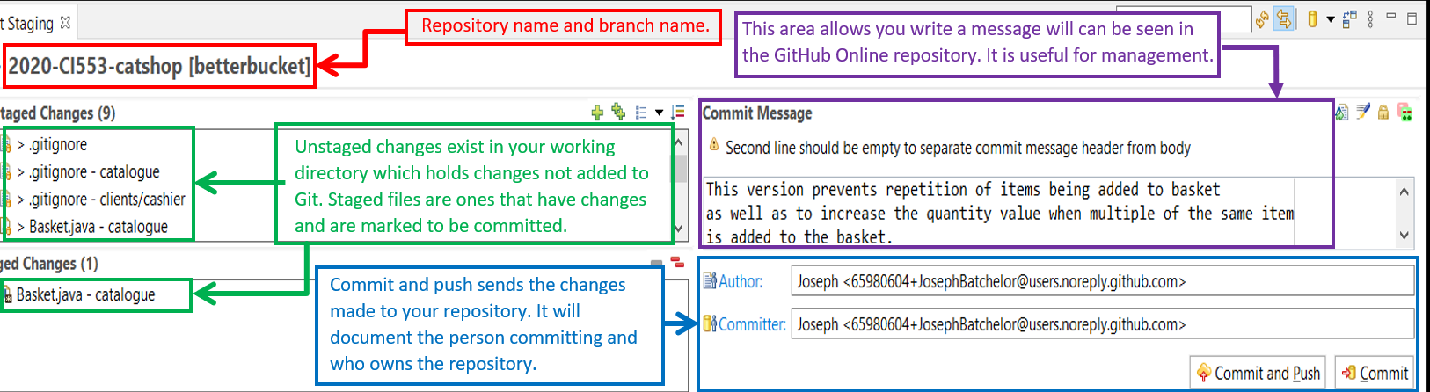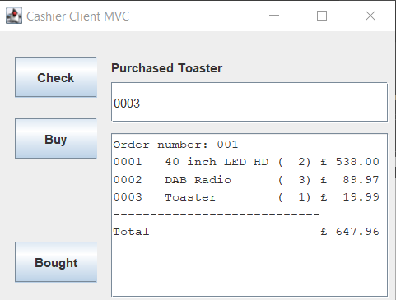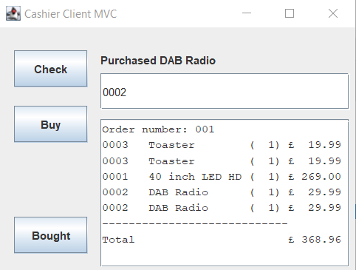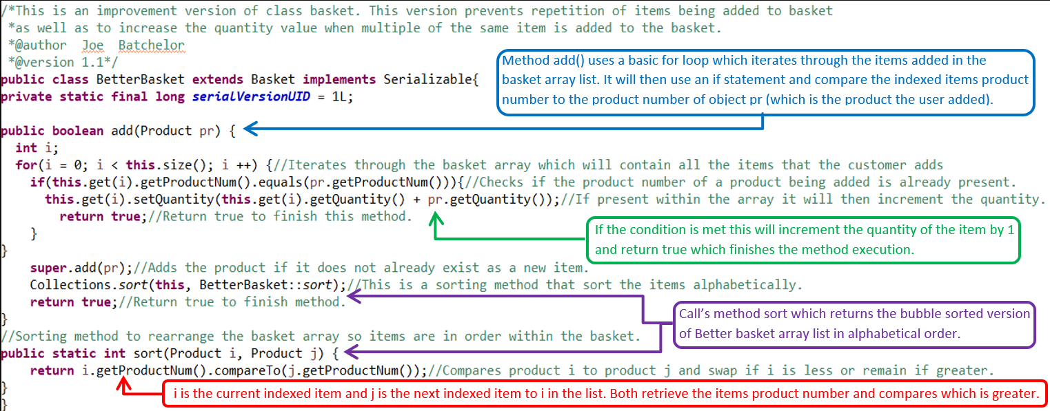

By using the integrated git features I was able to commit my changes made on this branch to my local machine and then push it to my git repository online. This can now be accessed via git and can be distinguished by the comment I left.

The implemented changes to better basket makes cat shop look more professional as well as it provides clarity when reading the added items.

**VS**

**Better basket Junit Testing**

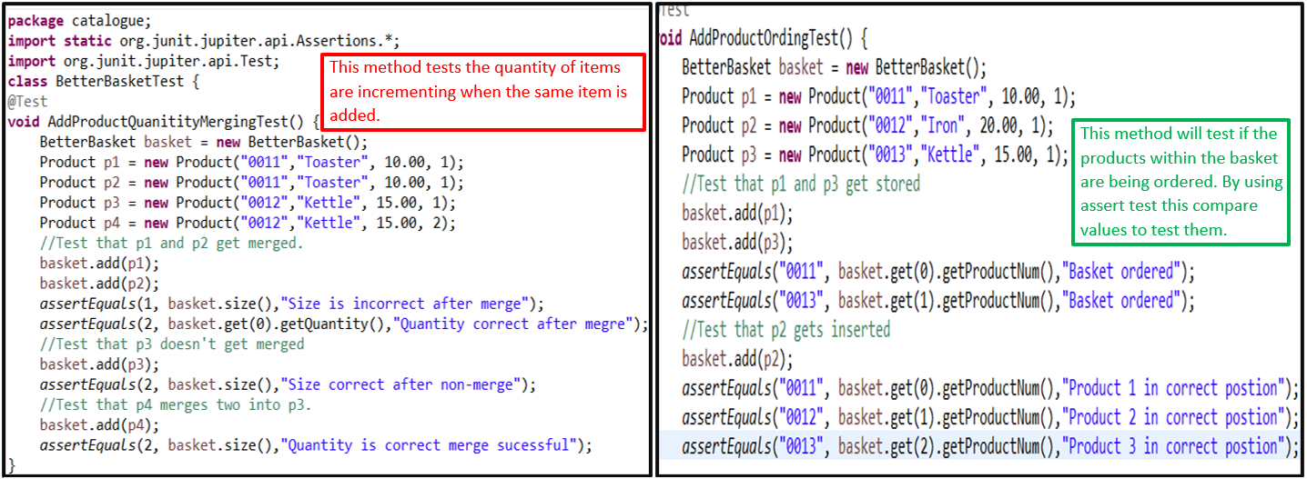

I have implemented a BetterBasketTest class which utilises Junit to test the recent changes add to better basket.

**Better Cashier Model development**

**Version 1.0**

Better cashier model is a new separate branch which focuses on improving the clients.cashier package. Version 1.0 implements a remove button to remove the last item added to the basket.

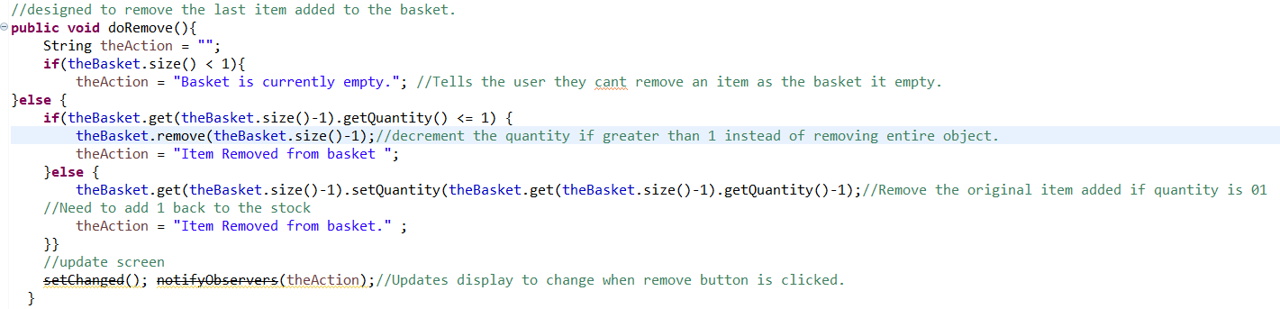

I added a button model to class cashierView with functionality for the button in class cashier.Model. I have also redesigned the view of the cashier.cleint window by introducing different colours, fonts and layout which has completely reworked the functionality. Below is the difference between the original and the new implementation .

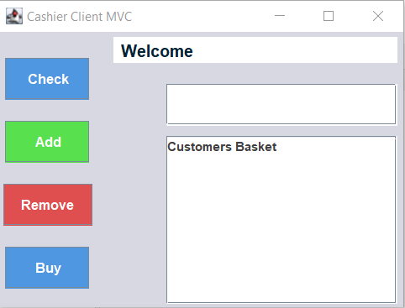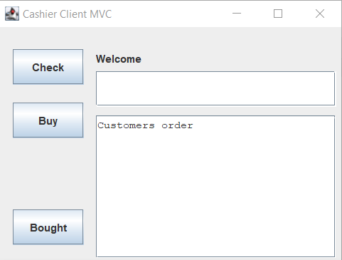

**VS**

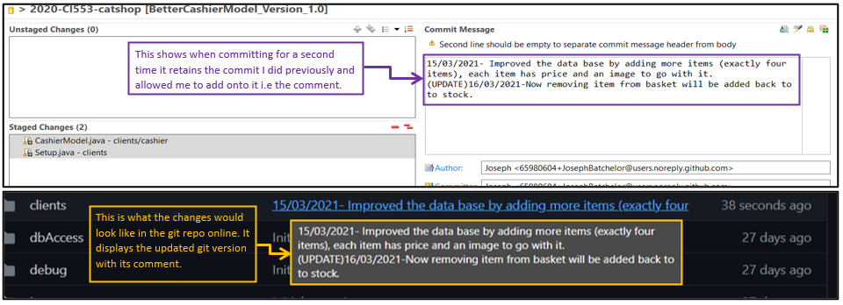

Even though I have already committed and pushed this branch I am able to do it multiple times until I feel this version is complete.

**Better Cashier Model development**

**Version 1.1**

Below is a demonstration of me using the integrated git feature to create a new version (1.1) of cashier model. Which will introduce a quantity text area which allows users to add items in bulk instead of adding it to the basket one at a time.

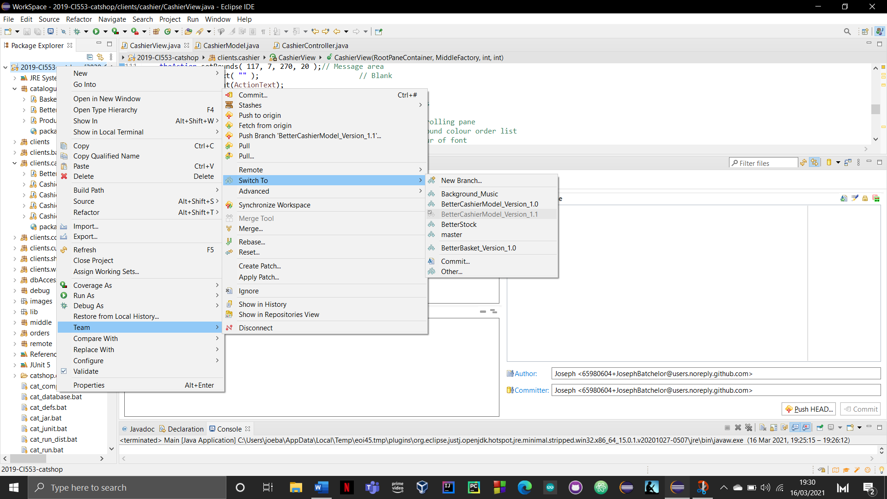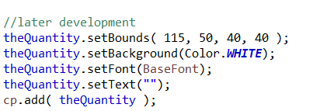

I implemented a text field called theQuantity in cashierView which takes user inputs.

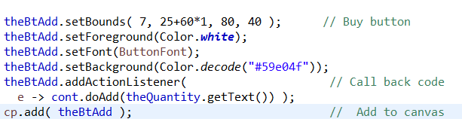

I then added an action for the add button to read the text from theQuantity input.

Some alterations were required for method doAdd() in class cashier Model in order for this feature to work.

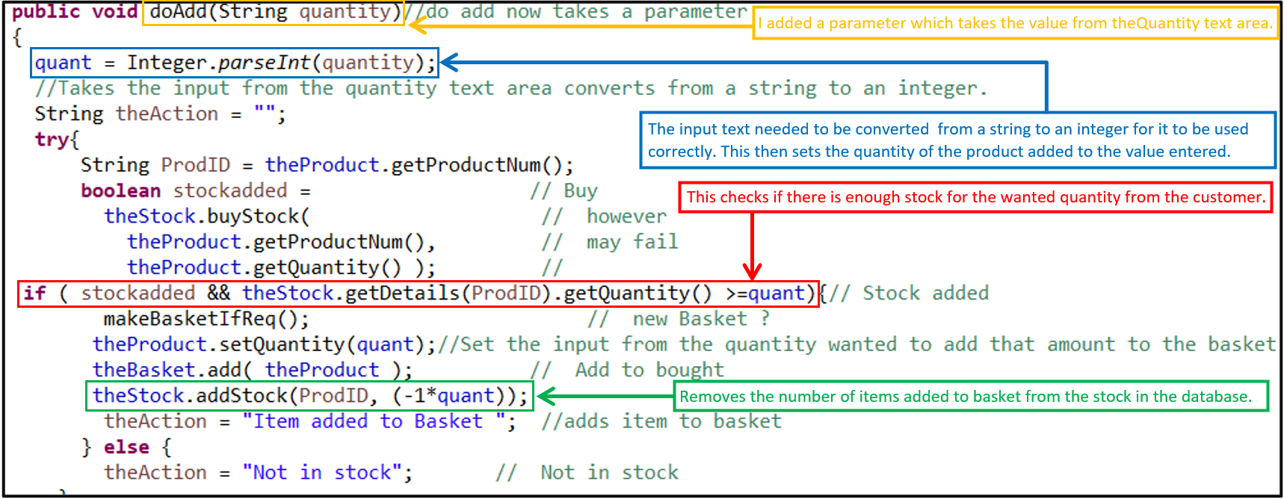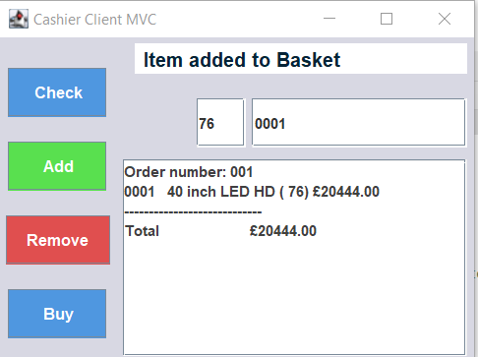

Implementing this feature provides a greater and easier user interaction as previously you would have to constantly check if a product is in stock and then add the product you wanted 1 by 1 which was not efficient. This method makes shopping quicker and easier.

**VS**

**VS**

**Better Cashier Model development**

**Version 1.2**

Better Cashier Model Version 1.2 branch introduces the ability to search for items via their name or with keywords found in their name. This consisted of makes some changes in method docheck() in the CashierModel.

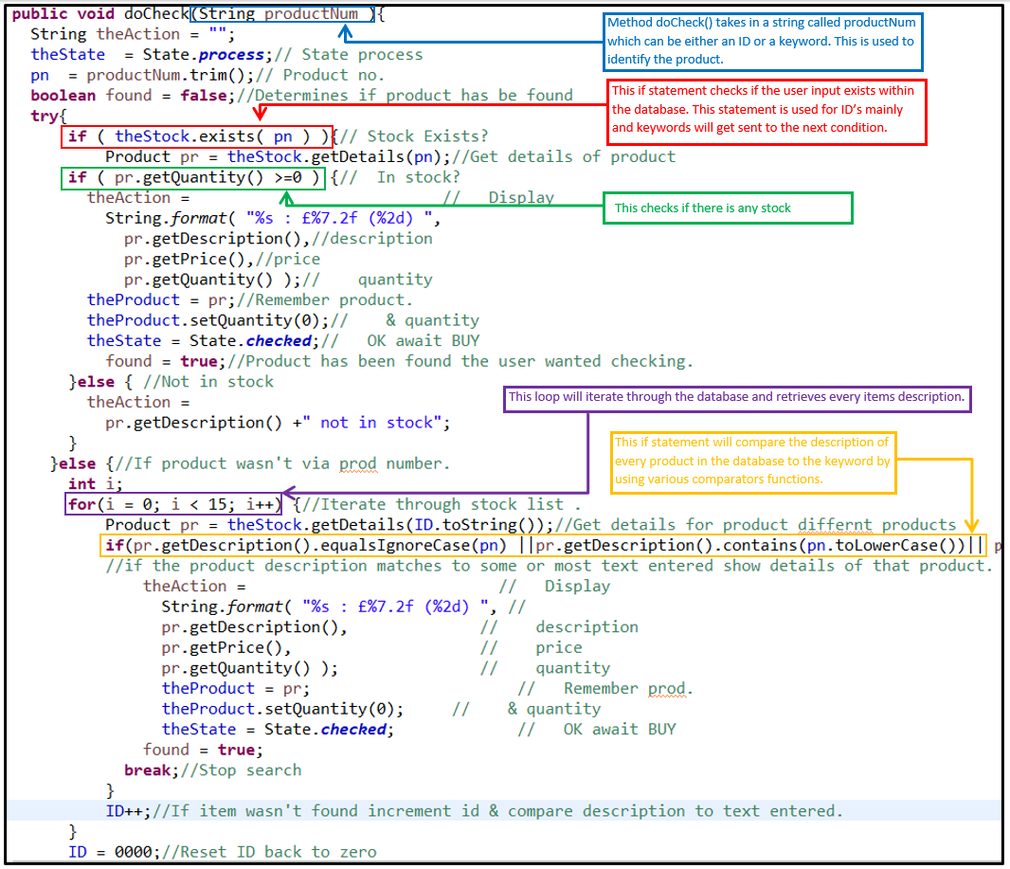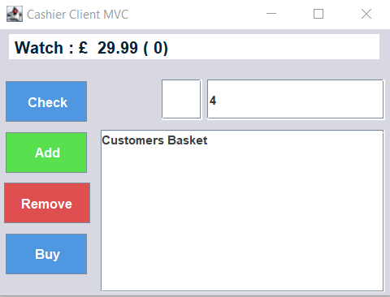

This makes searching for items more like a traditional shop and easier to find items.

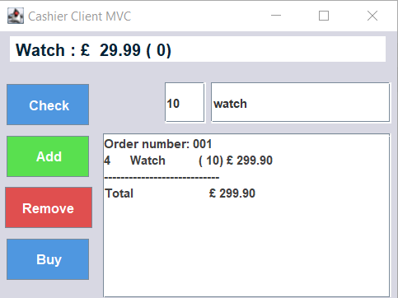

**OR**

**Better Cashier Model Junit testing**

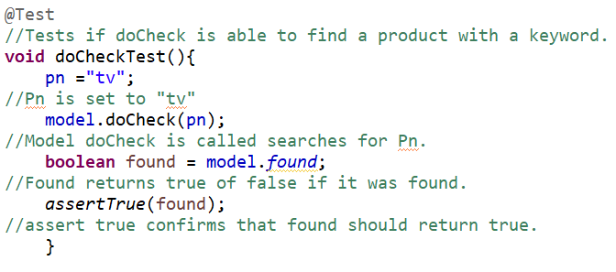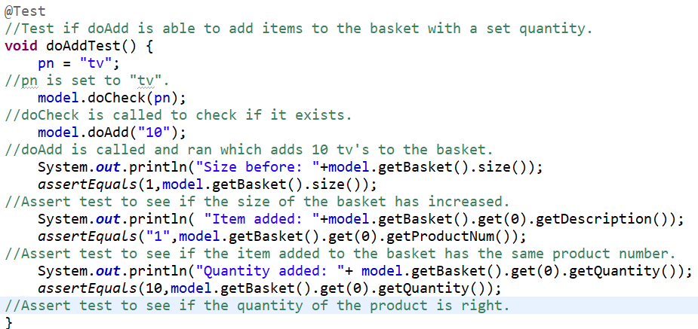

I have added Junit testing for better cashier model branch which tests each method in class model. The first set of tests check if method doCheck() and doAdd() are capable of finding items with the use of keywords and the ability to add those items into the basket.

Method doRemove() will test if it is capable of removing the last item added to the basket and adding it back to stock.

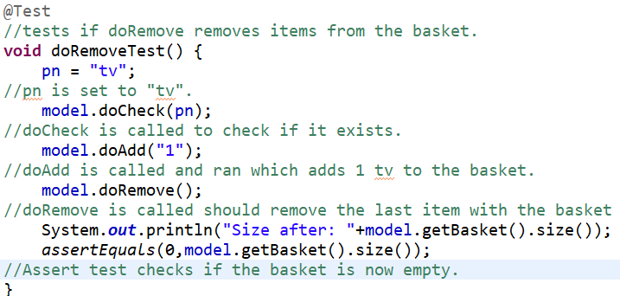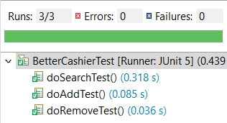

**Better Stock Development**

**Version 1.0**

Better stock Branch adds more stock for users to buy. This branch adds product into the database. The hardest part of development for this branch was finding the correct images to use for the added products.

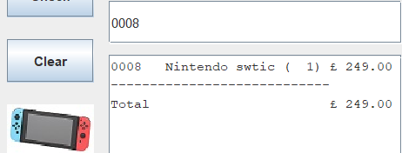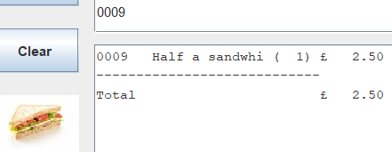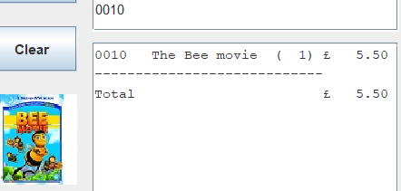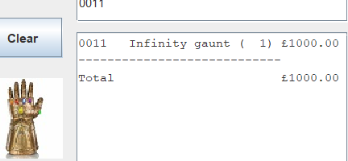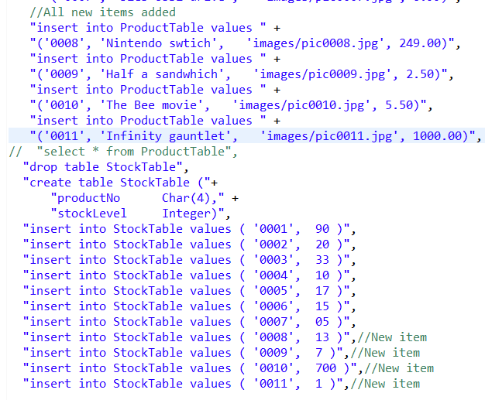

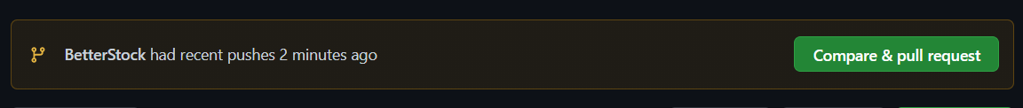

Checking on GitHub if my push was received by the online repository. The merge was approved which means no conflicts were present.

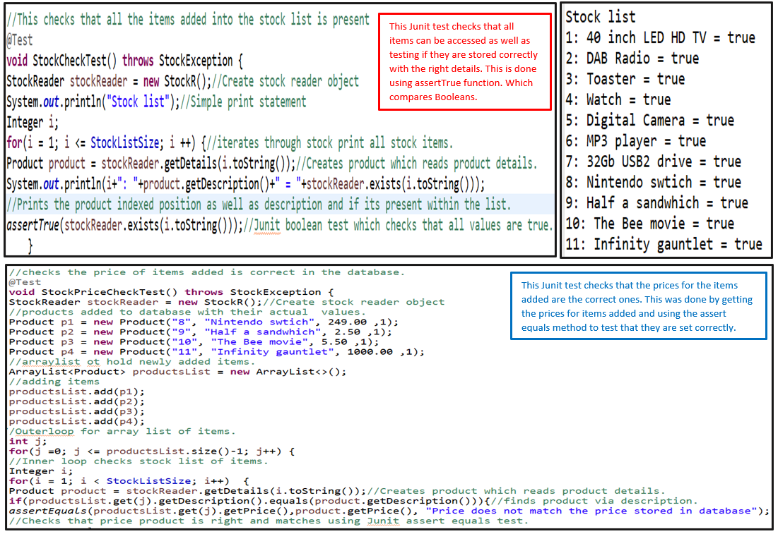**Better Stock Junit Testing**

I created Junit tests which check the current stock of all items in the database making sure they were accessible and stored correctly.

**Advertisement client development**

**Version 1.0**

Advertisement is a new client who introduces different types of iterating advertisement for the user to see. I had to create a new package which will house my advertisement classes . Additionally, I need to add the client into class main so that it will appear when ran.

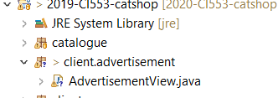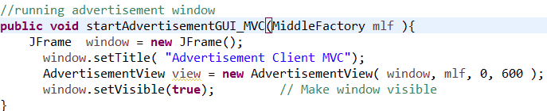

In order for the different advertisement images to iterate through each other I created a timer where each image will change when a certain value in seconds is met. Every 10 seconds a new image will be displayed. Below you can see the images chosen.

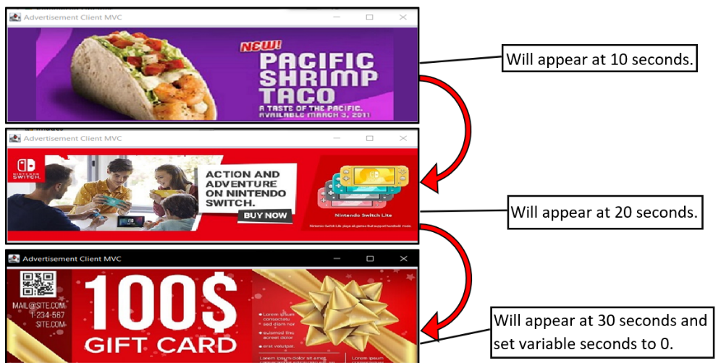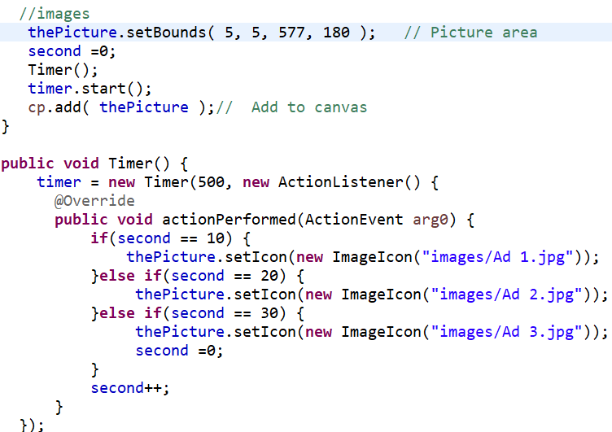

**Merging branches**

With the different branches made some have features that others do not such as my Cashier model version 1.1 branch does not have the updated stock in the Better Stock branch. Instead of copying the code over manually I can do what is called a branch merge which combines the two branches together. By using the integrated git functions, I was able to push the changes made from my better stock branch into my Cashier Model version 1.1 branch.

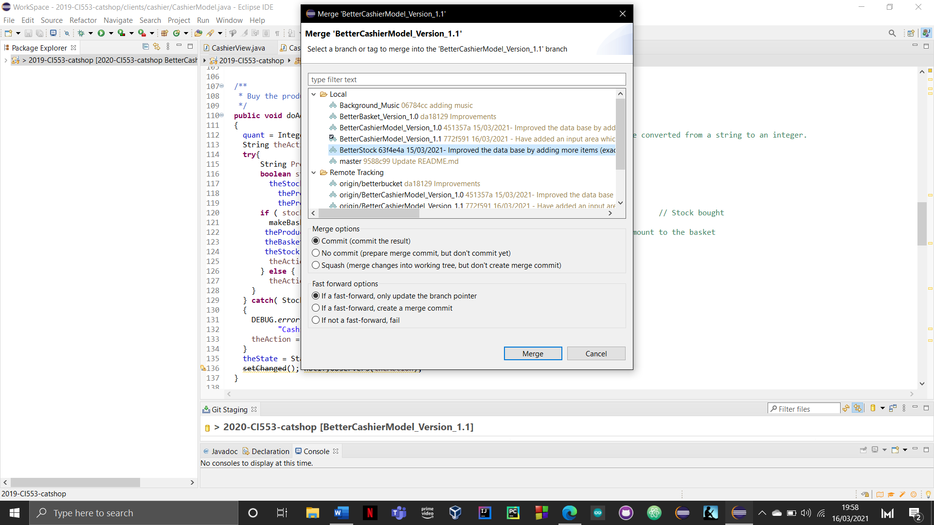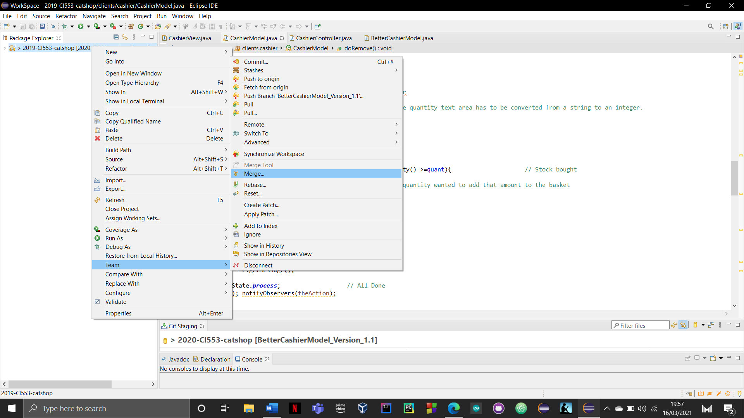

This is the aftermath of the merge it shows what commits have been pushed into my better cashier model branch.

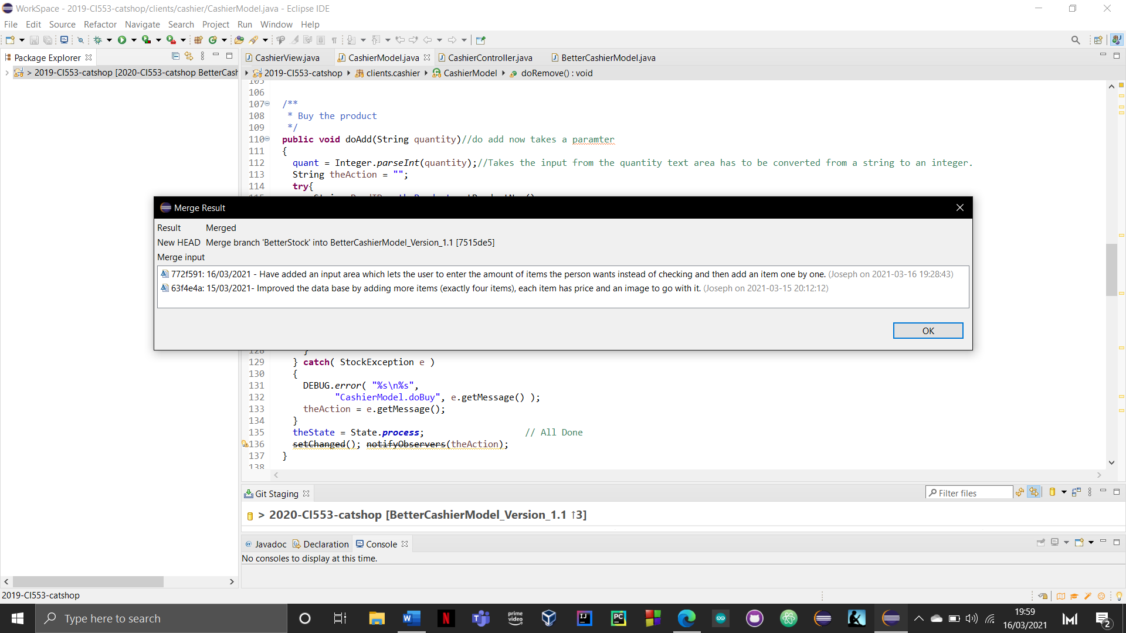

Using Github I was able to see the merge in better detail of the changes made when merging. By clicking of compare on the select branch and then finding then the correct commit. You are able to see a more detail version of the merge.



Every line below highlighted in green and has a plus next to it are recently added pieces of code. Everything highlight red and has a minus is code that was removed during the merge. Not only does it show the merge of code it shows which files have been added.

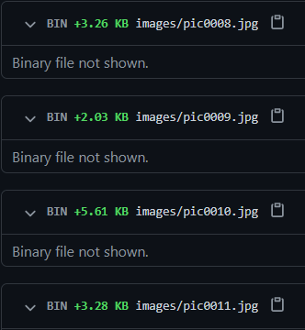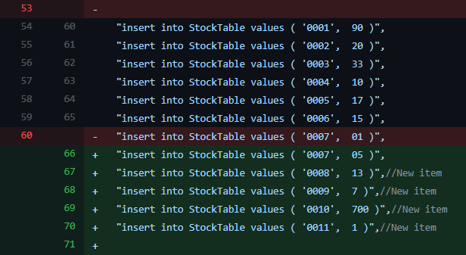

**Easter term Catshop version 1.1 and branch release**

I had schedule to create a version 1.1 release of the cat shop software the week we broke up from Easter as a new point of development. This consisted of making a new branch from the master branch and merging every implementation and improvements made into the Catshop Version 1.1 release branch. This will be my new developing point as it will include all the functionality and design so far.

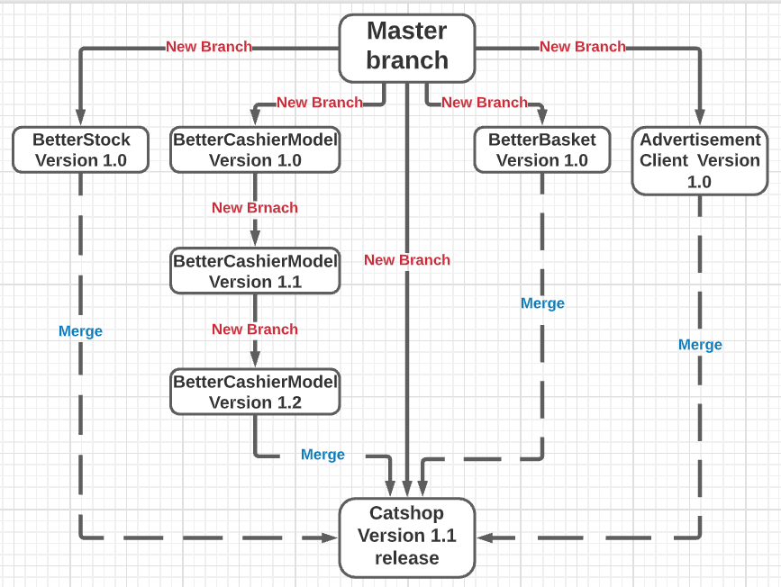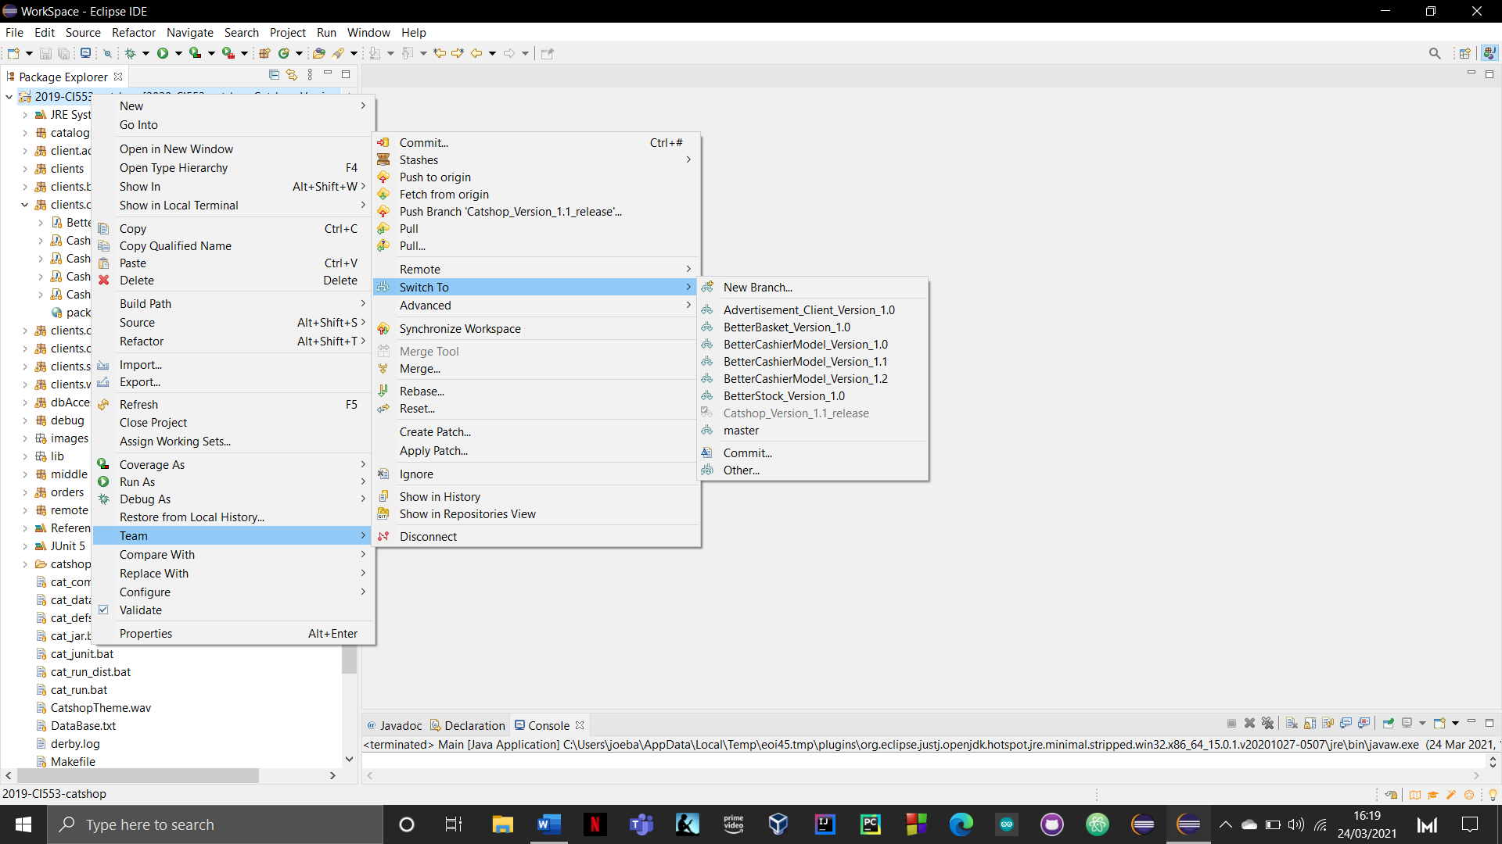

This is my Github catshop Version 1.1 alpha release where users can download and use this version. Now I can build from this new branch instead of from the master branch.

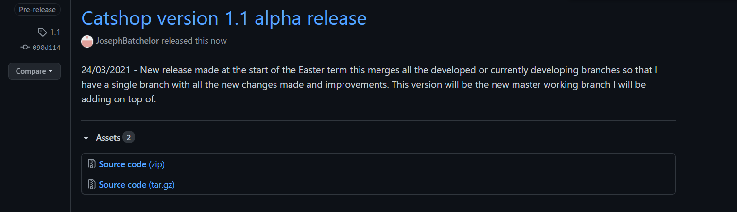

**Product Review development**

**Version 1.0**

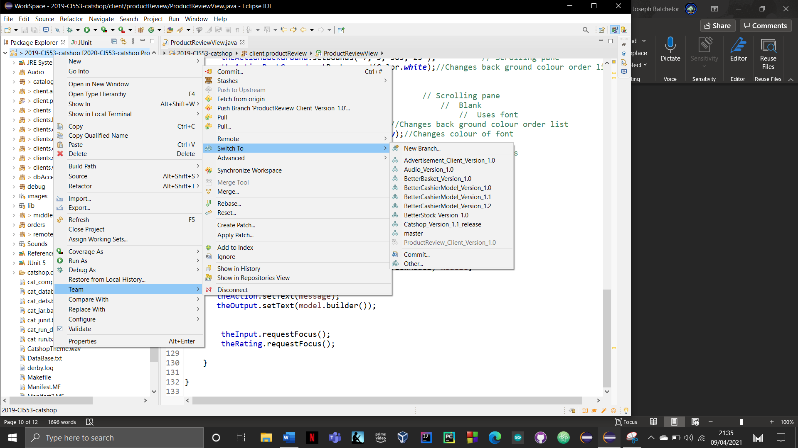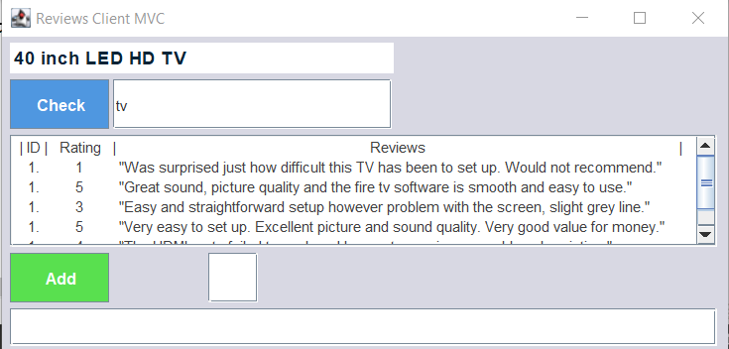

Product review is a new client that I have introduced to catshop which allows users to see reviews regarding different products. Below is what the new client looks like.

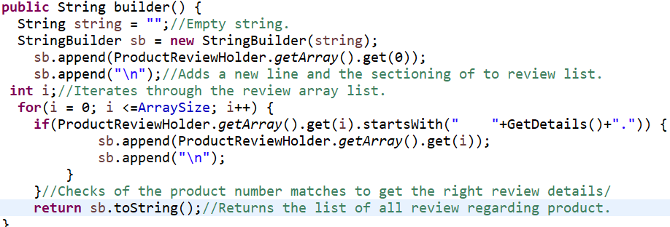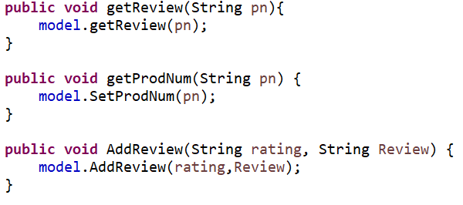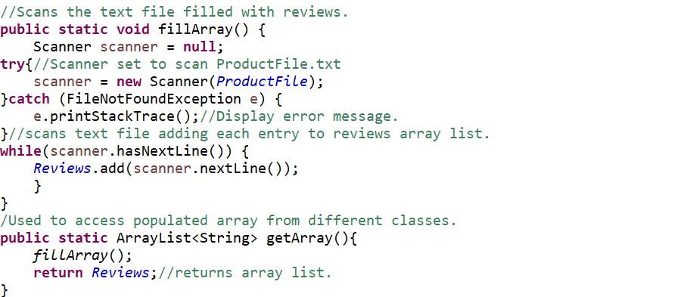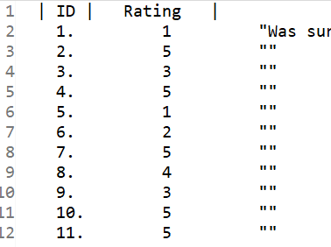

In the controller class I have crated three main methods that class model provides functionality for. These methods will take user interaction and find the correct product with the use of either the product ID or keyword searching.

Below is method getReview() found in class model, this method will take user input and identify the product they are looking for and save the ID to be use later for displaying the list of reviews.

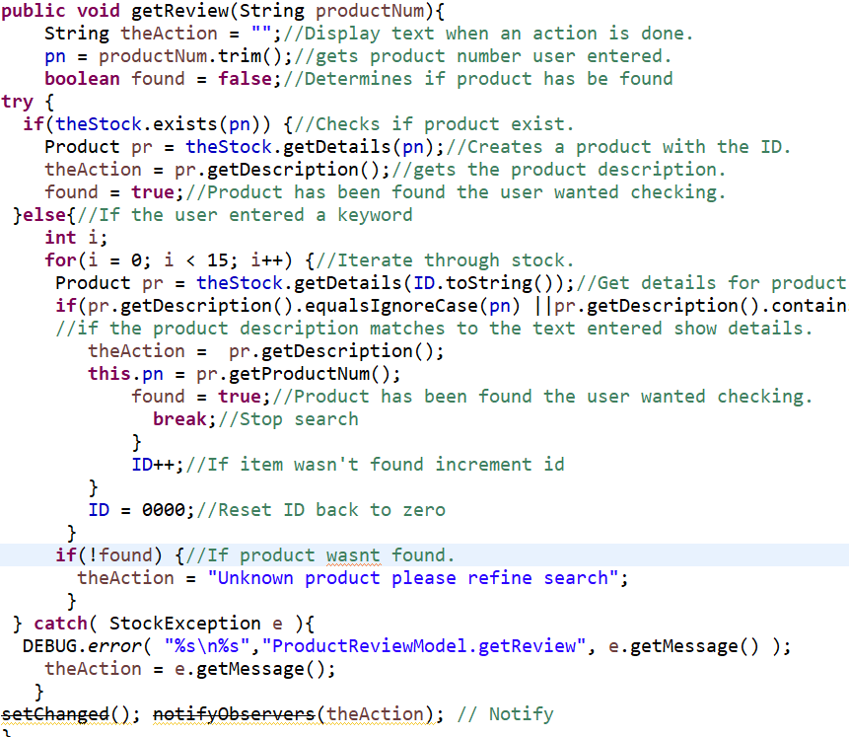

With this development task I introduced serialisation with the use of a text file. This can be found within the Product review package and its job is to store all the reviews for each product. Below is an image demonstrating the format of how the reviews are stored. This allows for permanent data to be stored as well as meaning users will be able to add reviews. Accessing these reviews are done by scanning the text file and storing all the elements into an array as seen above previously.

Displaying the review is done using string builder to append all the reviews together. In method builder a for loop will iterate through the array which contains the reviews and appends them to the string created. This matches them with the use of the item’s product number.

**Product Review development**

**Version 1.1**

This development task introduces the ability to added reviews for different products. This means proving a rating and a little bit of text. These reviews are store permanently in a text file which means reviews can keep growing.

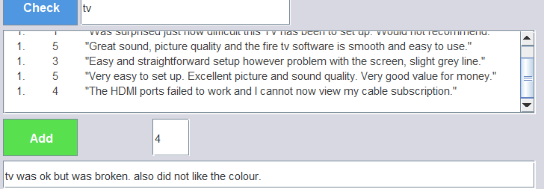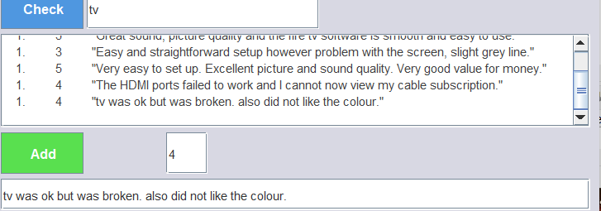

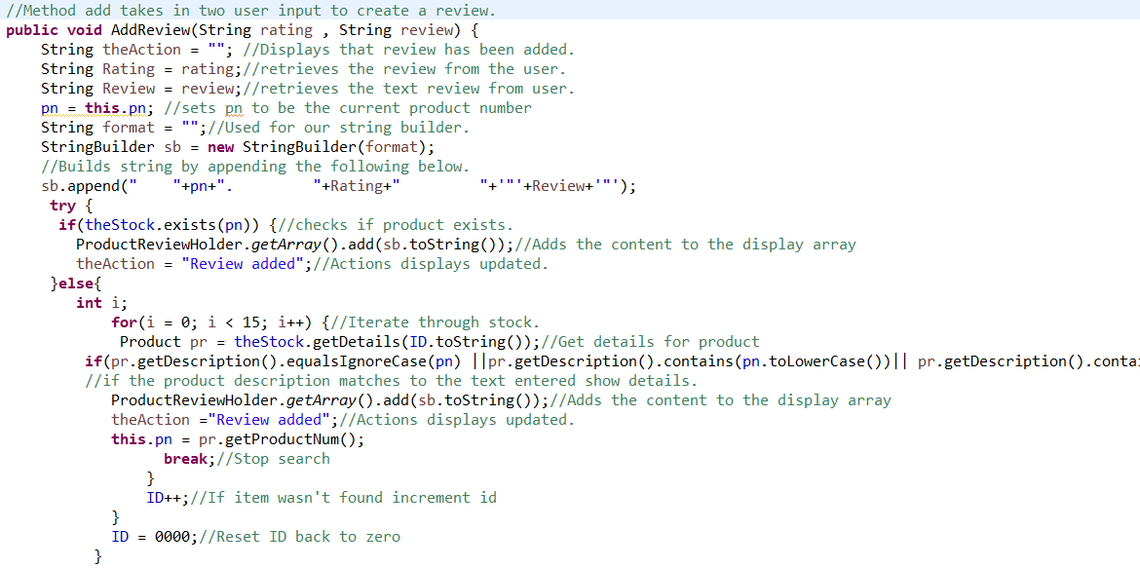

Below is the AddReview() method which will take two strings and convert them into a format using string builder.

**Product Review Junit Testing**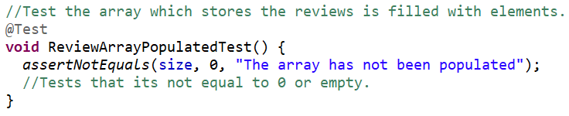

I have introduced two Junit tests for my product review branch which will focus on the reviews for each product.

The first junit test will test the array list used to store product reviews. The test will see if the array list is populated when the reviews are scanned and added to the array list.

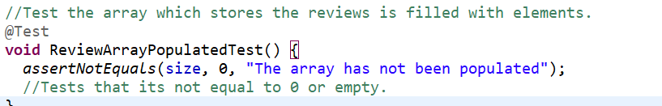

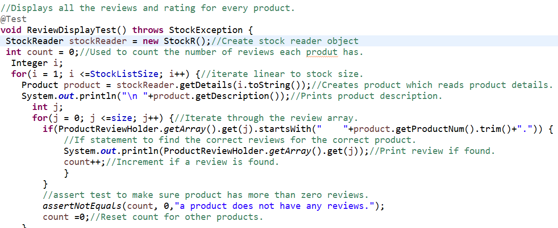

The next Junit test checks that all products have at least one review to display.

**Better Customer client development**

**Version 1.0**

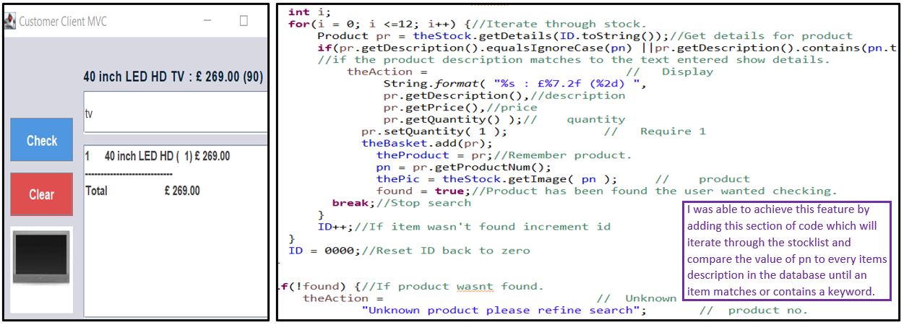

I have redesigned Customer client as well as improved the search feature, allowing users to use keywords and or IDs to search for items.

**Better Customer client development**

**Version 1.1**

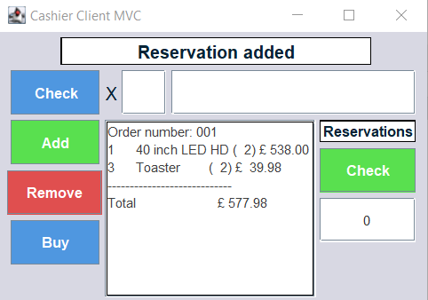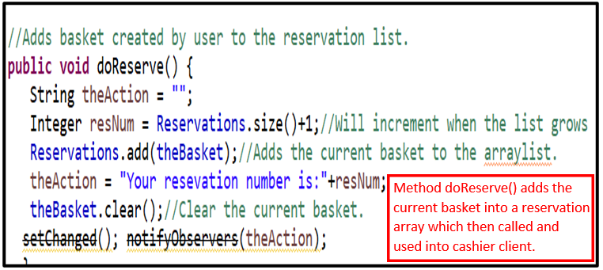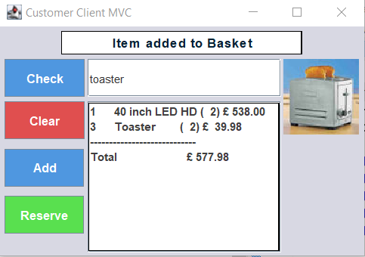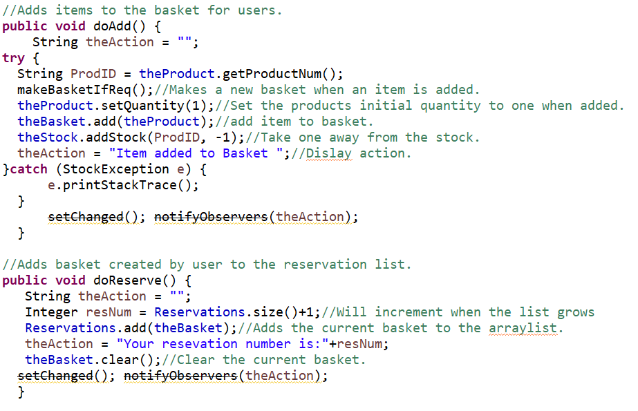

Additionally, this meant I had to redesign the cashier client to accommodate this new feature. When the correct reservation number given from the customer client is entered. Cashier it will add all the items into the basket to be paid for or for more items to be added.

This branch introduces a reservation feature which allows customers to reserve items and pay for it later. By adding two additional methods into the CustomerModel class called doAdd() and doReserve() this will add items to the basket and reserve them for later use.

**Better Customer client junit testing**

I created junit tests for each of the many methods in class model. These are designed to test each one’s functions correctly.

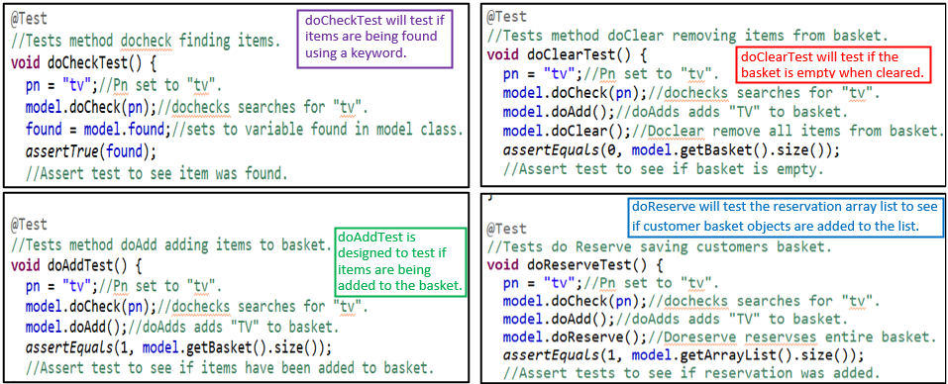

**Catalogue client** **development**

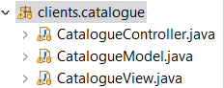**Version 1.0**

Catalogue is a new client I have introduce to catshop which allows users to browse through the various products. This also introduces a search feature which allows users to use keywords or the ID to find products. It handles multiple matches by picking the item with the lowest product number.

**or**

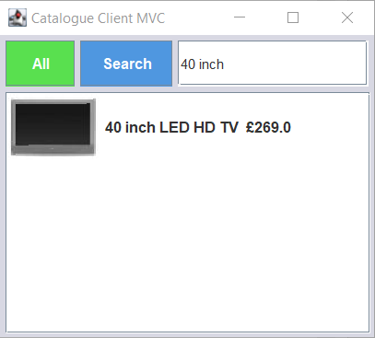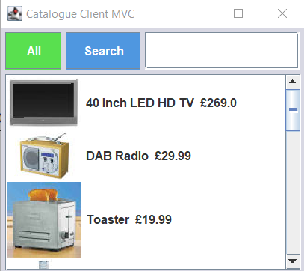

Implementing this list of products with both text and images became a tedious task. Using a Jlist allowed me to insert an image and text in a single row easily. however, inserting multiple images required me to create an inner class in class view call “product Renderer”.

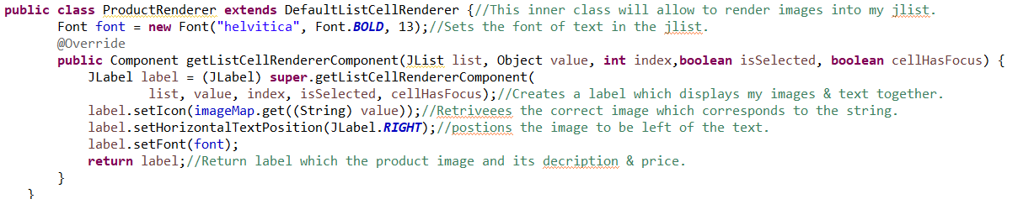

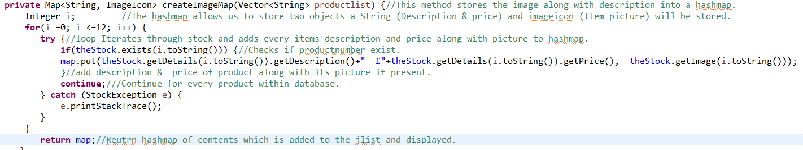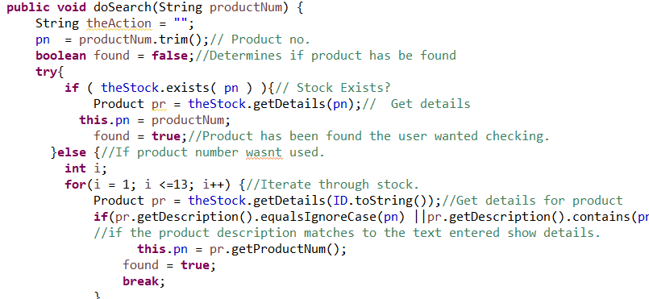

Creating a HashMap allowed me to store both strings (description & price) and image of the product because I was dealing with multiple items this made retrieving and displaying the right product easier. Method CreateImageMap help change the images displayed.

Class Model provided necessary the methods that for user interaction. Method doSearch allows the use of keywords and product numbers to search for precise items. Method doAll simply displays all the items when the user clicks the “all” button.

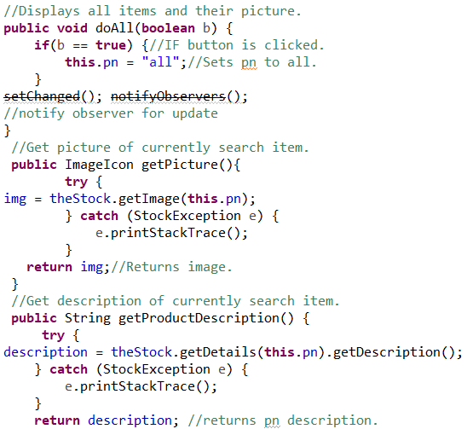

**Catshop version 1.2 and branch release**

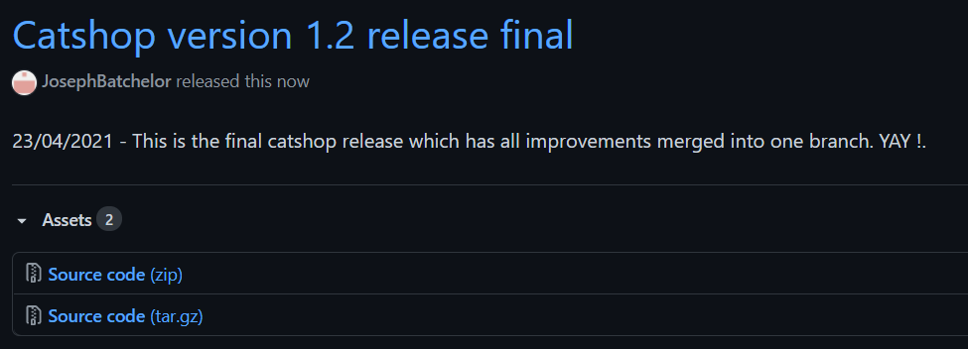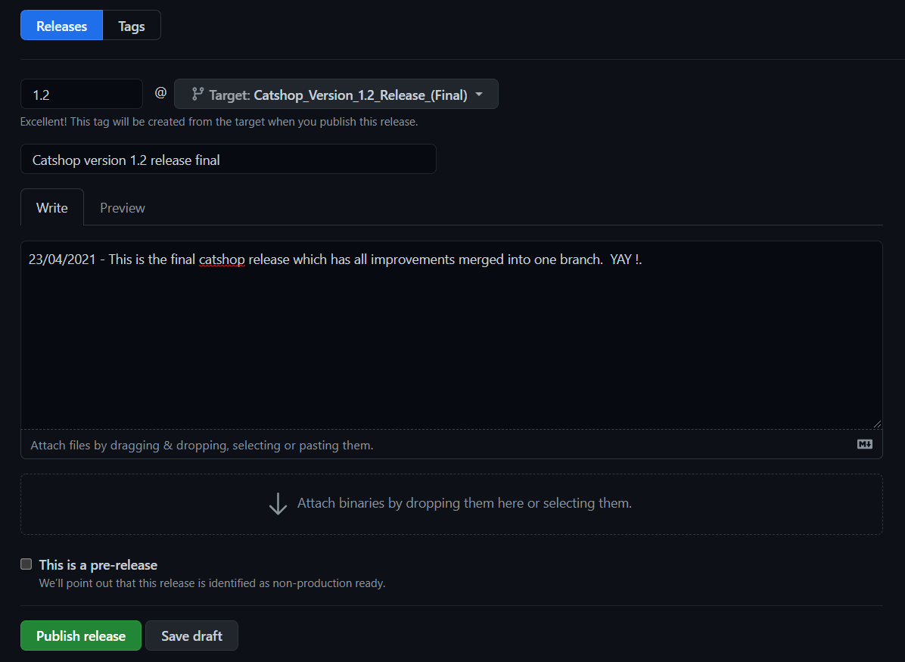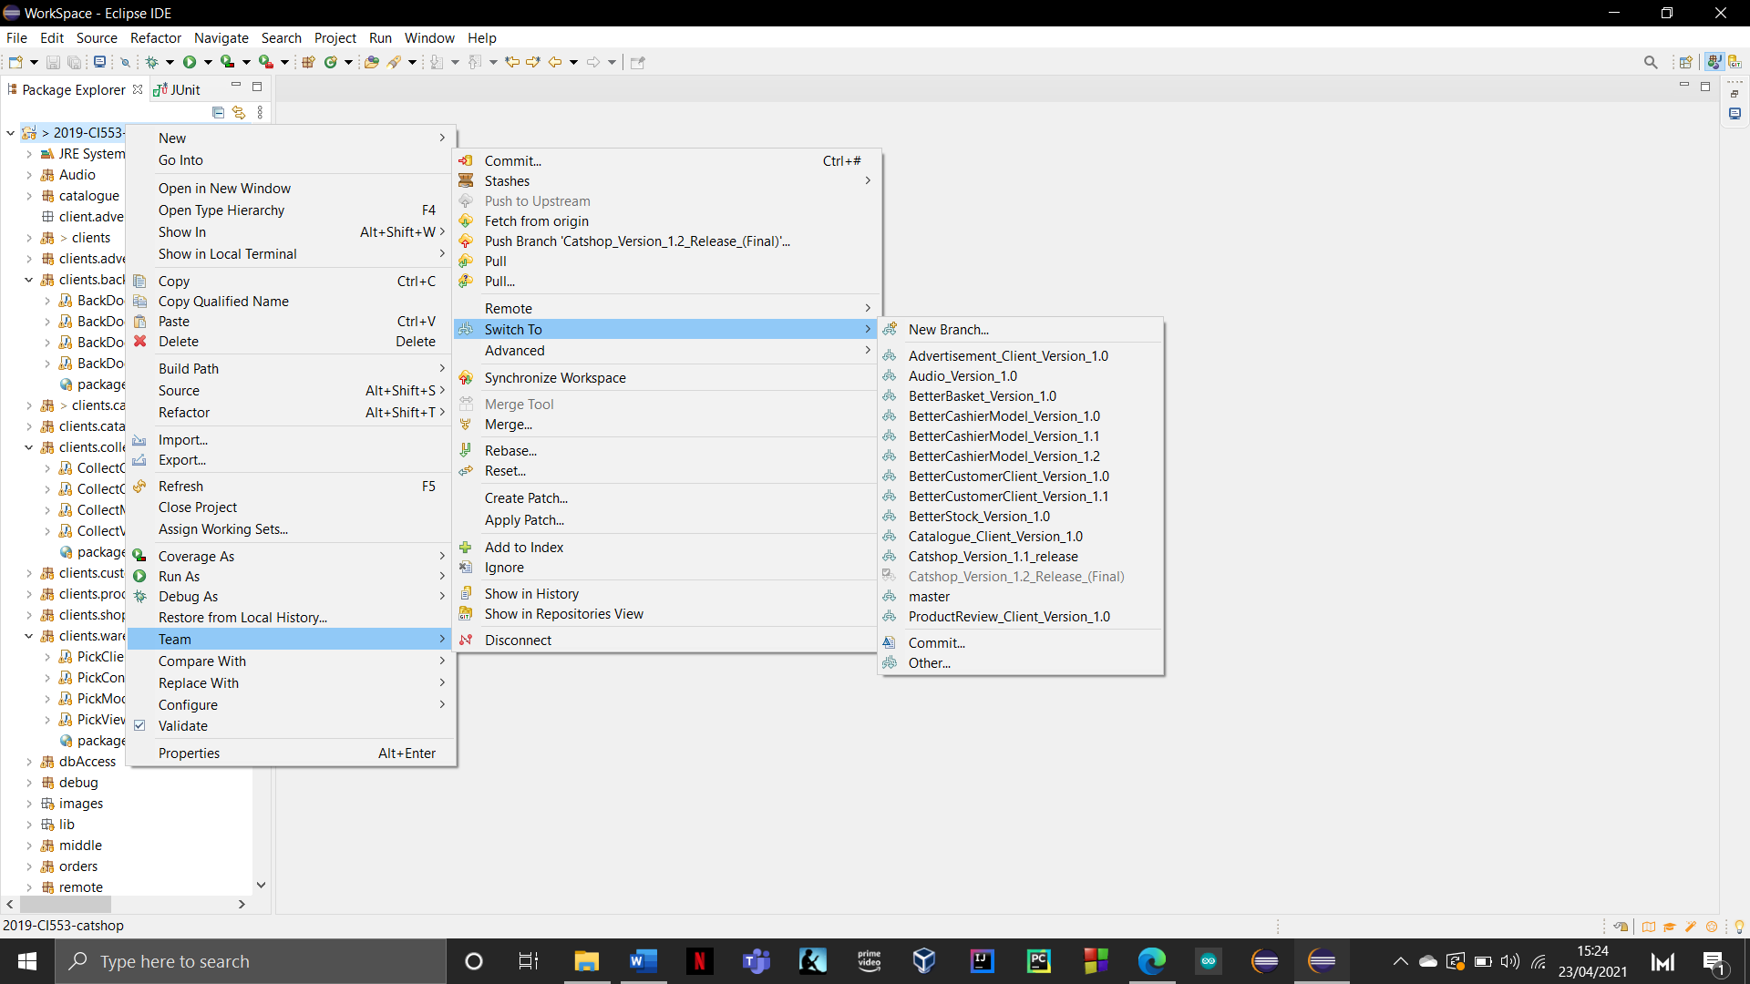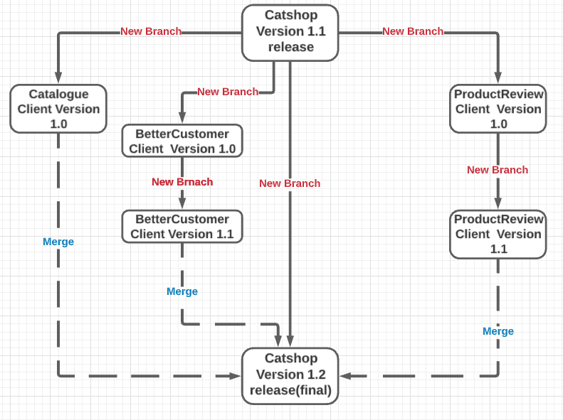

Catshop version 1.2 is the final branch of the catshop project which merges all the remaining improvements and additions into one. This will allow me to create the final public release on GitHub. Below is a uml diagram illustrating all the changes and branches added.

This is my final public release on GitHub. This includes my development and commits regarding all improvements and features added.

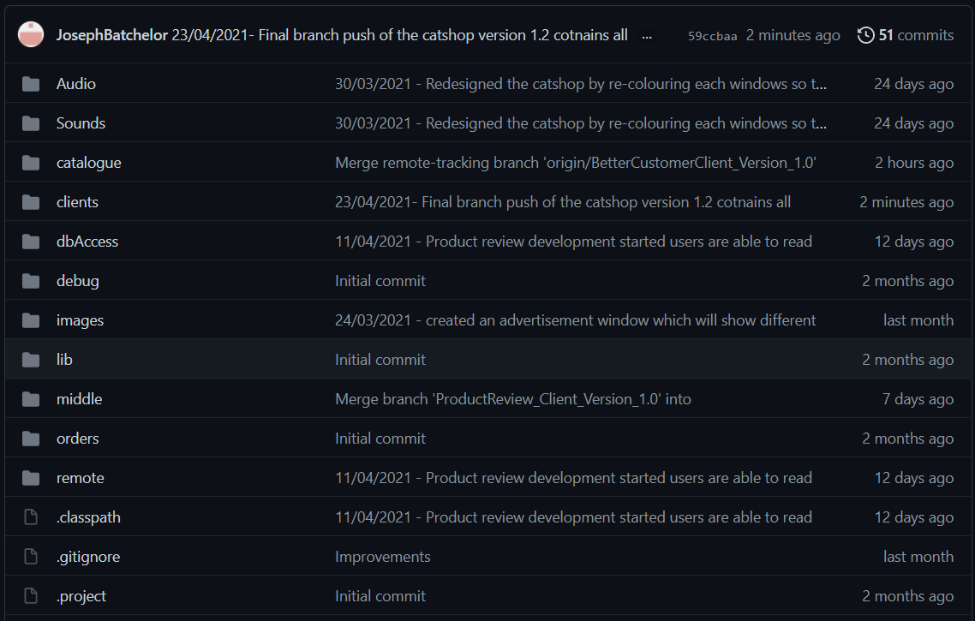

Below is what my final branch of catshop looks like with all of the commit comments displayed.

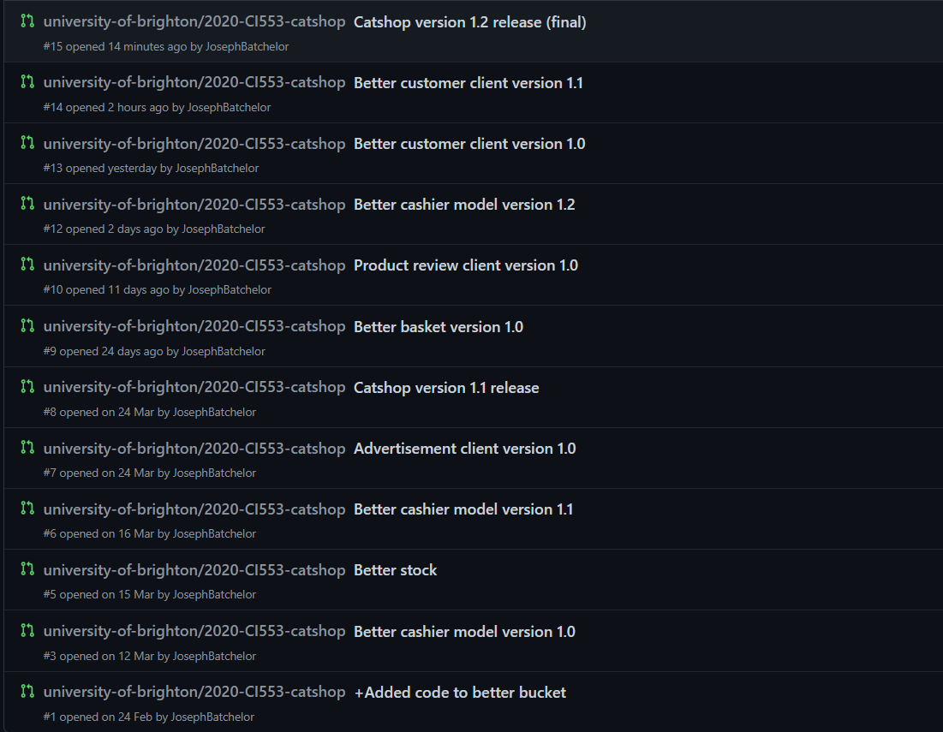

This is a list of all branches pushed to my GitHub respiratory online.

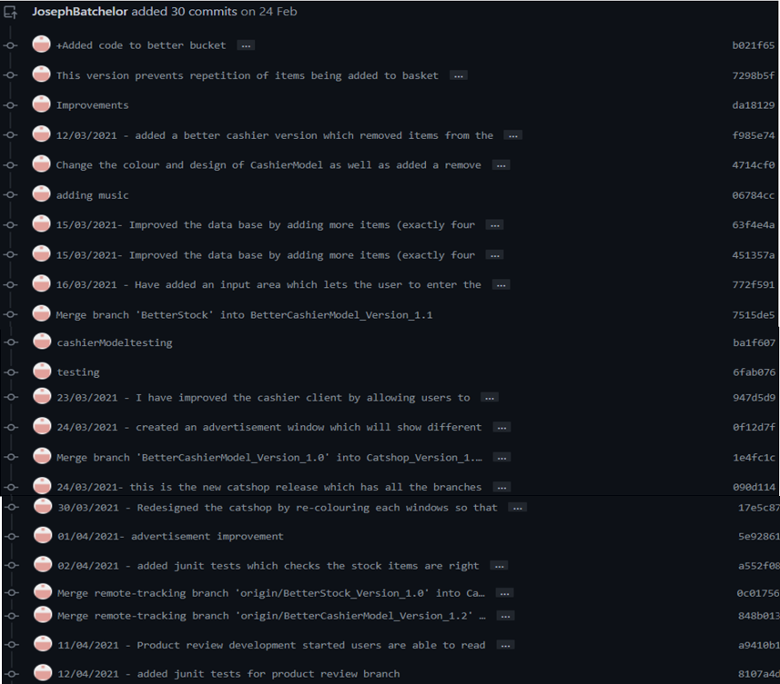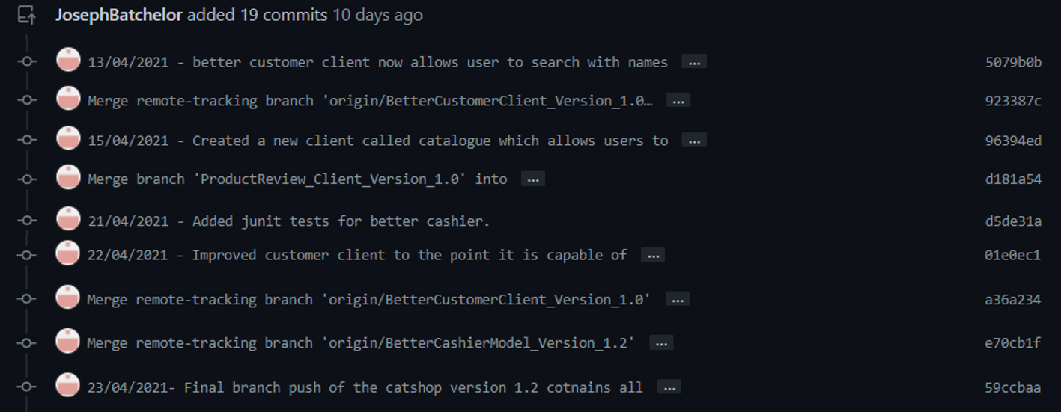

Below is the list of commits made during this project. These were spread across three months February – April . Each one describes what is introduced as well as a date stamp of when this was pushed.

**Jenkins’s integration**

This section is a walkthrough my Jenkins continuous integration for catshop as well as set up tutorials and an overview.

**Build pipeline**

Jenkins will allow me to continuously integrate my catshop projects so that they are ready for public realise. Below will be a tutorial that demonstrates how to build, test, and deploy better basket.

Log onto the Jenkins dashboard click on “New item”.

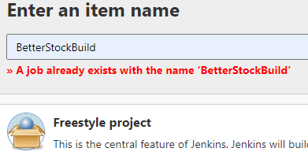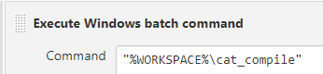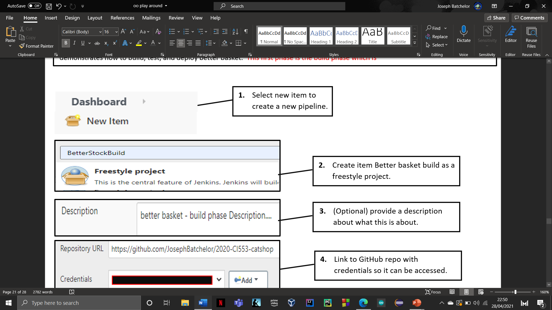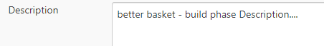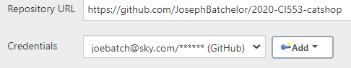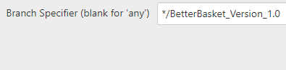****

1. (Optional) provide a description about what this is about.
2. Select new item to create a new pipeline.
3. Link to GitHub repo with credentials so it can be accessed.
4. Add a branch build which is the branch link.
5. Add a build step to the call compile script.
6. Create item Better basket build as a freestyle project.

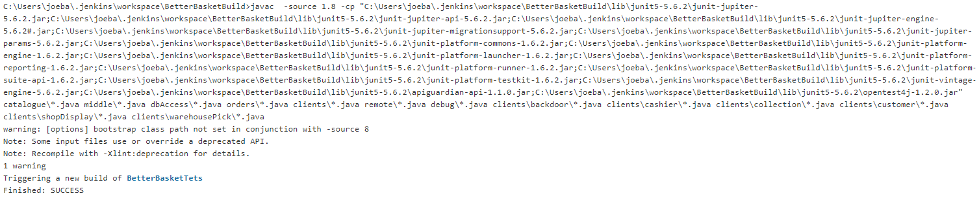

1. Console display of build phase success.



**Testing pipeline**

The test phase is designed to run all tests created on the branch. This provides information regarding the successfulness of the tests.

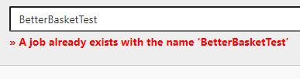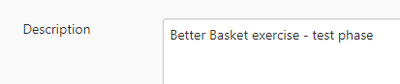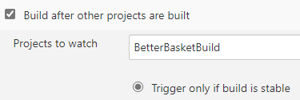

1. Select new item to create a new pipeline.
2. Create a new pipeline called Better basket test as a freestyle project.
3. (Optional) provide a description about what this is about.
4. Add a build step to the call compile script.
5. Link to GitHub repo with credentials so it can be accessed.
6. Add a branch build which is the branch link.
7. Go to build triggers and select build after other projects and enter better basket build this will compile better basket build before the test phase.

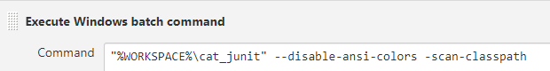

1. Add an additional build step listed “%WORKSPACE%\cat_junit –disable-ansi-colors -scan-class path”.

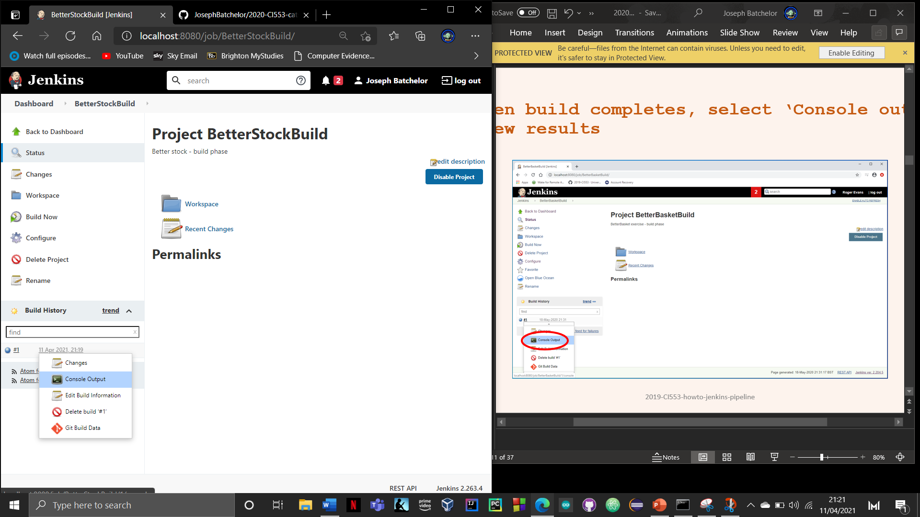

1. Apply changes and run build, then console output to see the success junits tests ran.
2. This is the output of the test pipeline with all tests ran and has finished successfully.

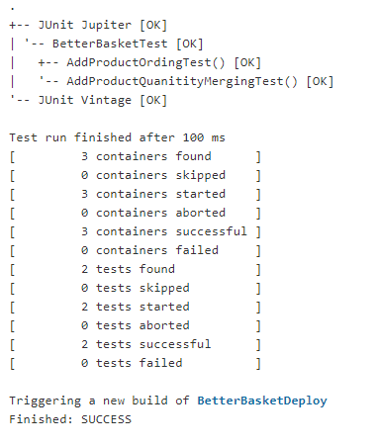



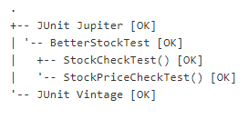

Below are results / output of the developed branches that functioned on Jenkins. This displays the junit tests and their success.

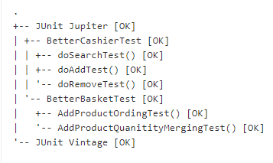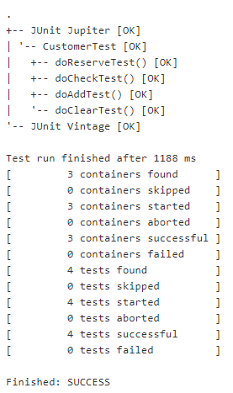

**Deploy pipeline**

This deploy pipeline is designed for continuous deployment and delivery it checks the flow of code and ensure the project is automated.



1. Select new item to create a deploy pipeline.

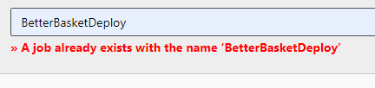

1. Create a new pipeline called Better basket deploy as a freestyle project.

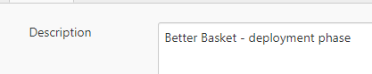

1. (Optional) provide a description about what this is about.



1. Link to GitHub repo with credentials so it can be accessed.



1. Add a branch build which is the branch link.

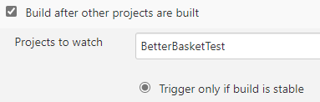

1. Go to build triggers and select build after other projects and enter better basket test.



1. Add a build step to compile branch code.

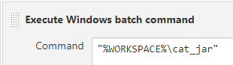

1. Add An additional build step “%WORKSPACE%\cat_jar”.



1. Apply changes and run build, then console output to see the success junits tests ran.



1. This is the deploy pipeline output which displays if this branch is successful.

**Creating views**

This section is to briefly demonstrate how to create a personal view to display separate data from the main view within the dashboard.

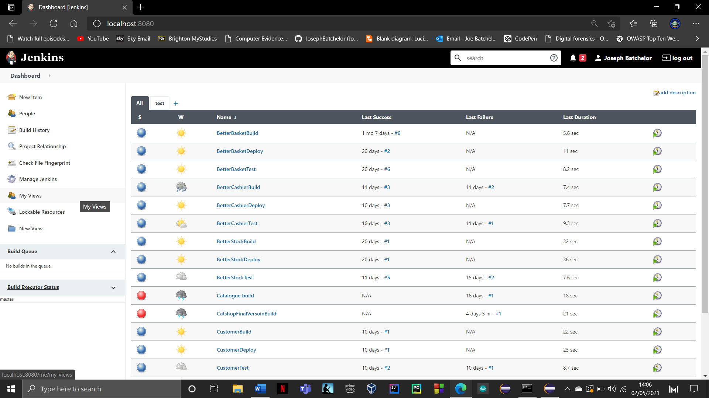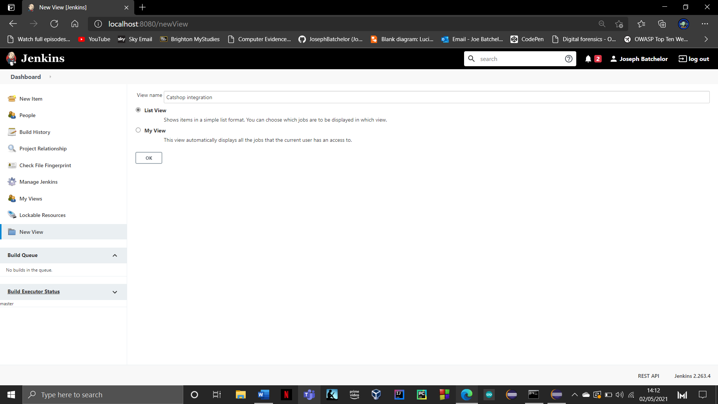

1. Click “new view” to start creating.

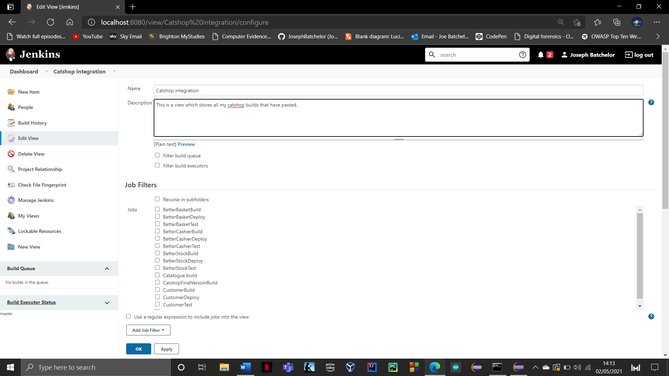

1. Next enter a view name and selected list view. This allow you customise which jobs you want and what to be displayed.

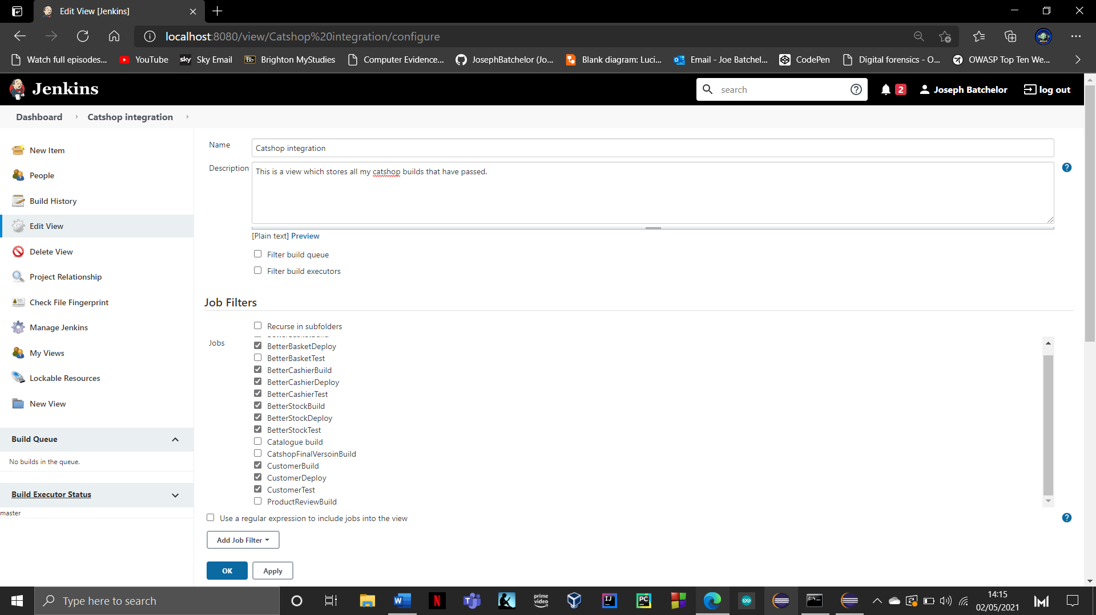

1. Next you will need to provide a brief description about what this views shows.

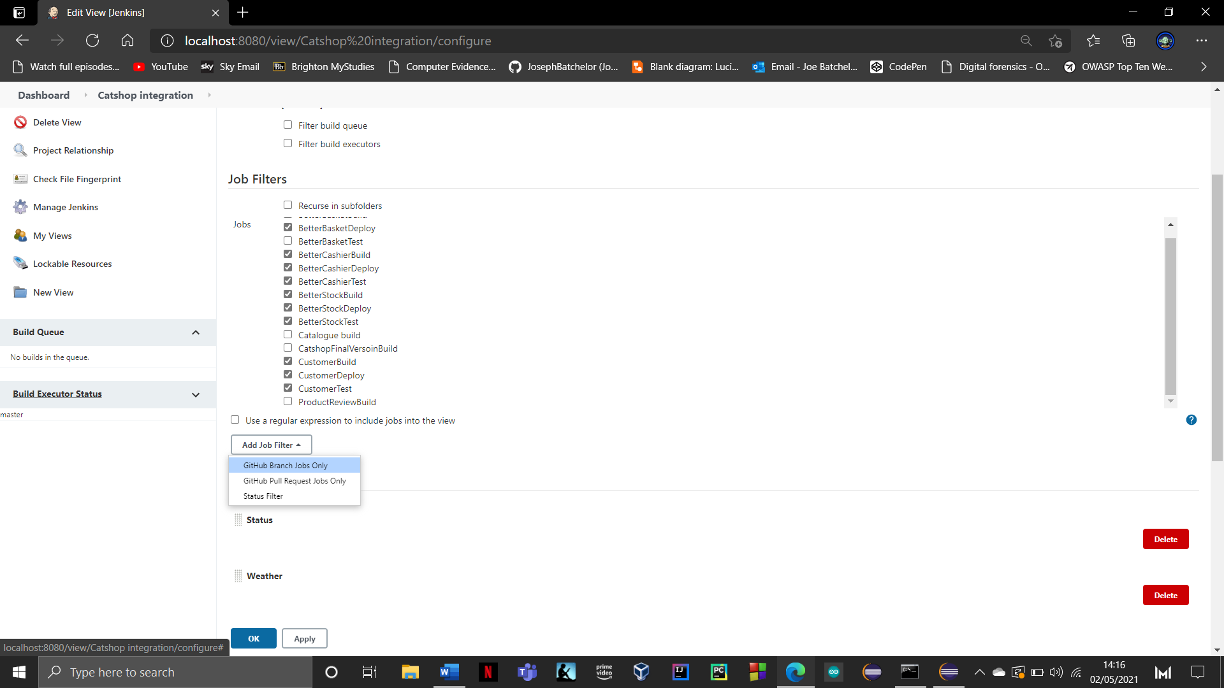

1. Next you will want to select the jobs you want to display. Simply tick the ones you want.
2. Next you want to add a job filter which in this case is to select “GitHub branch jobs only”. This will only display our branches.

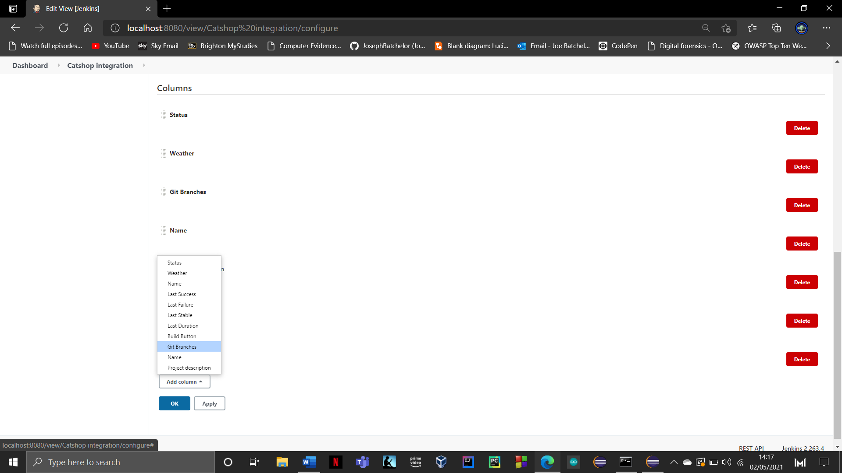

1. Now you can choose which areas you wish to display by adding a columns and dragging where you want.

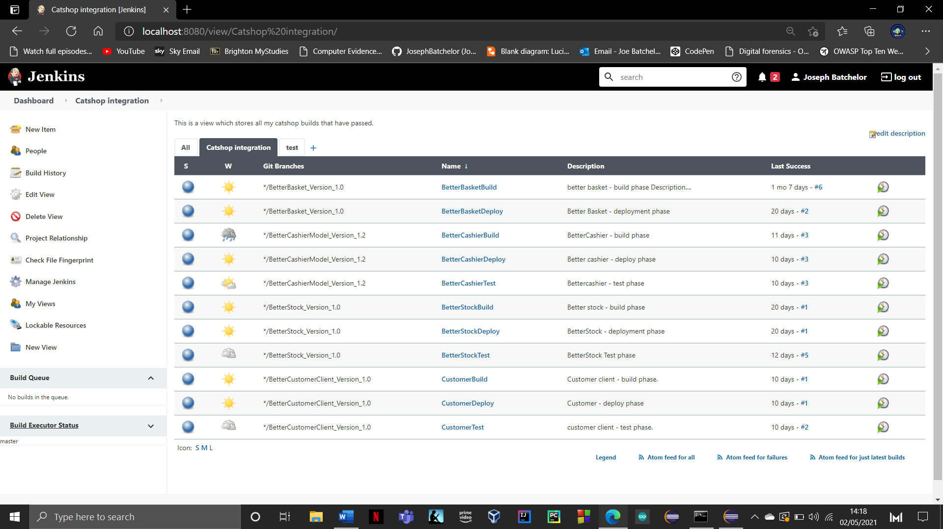

**Jenkins Overview**

Below is the list of Jenkins builds that I performed continuous integration with. unfortunately, not all integration were successful.

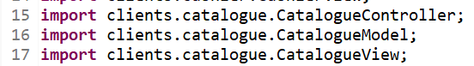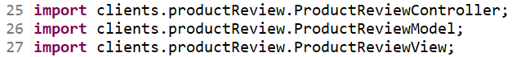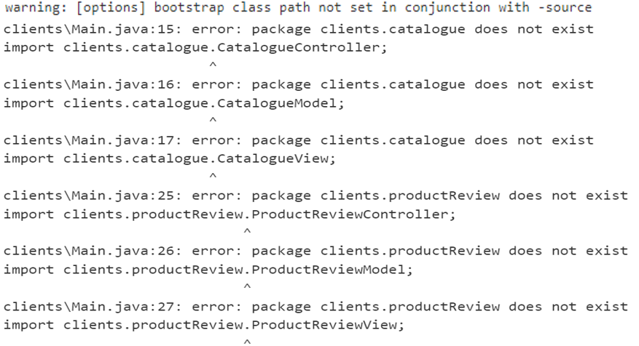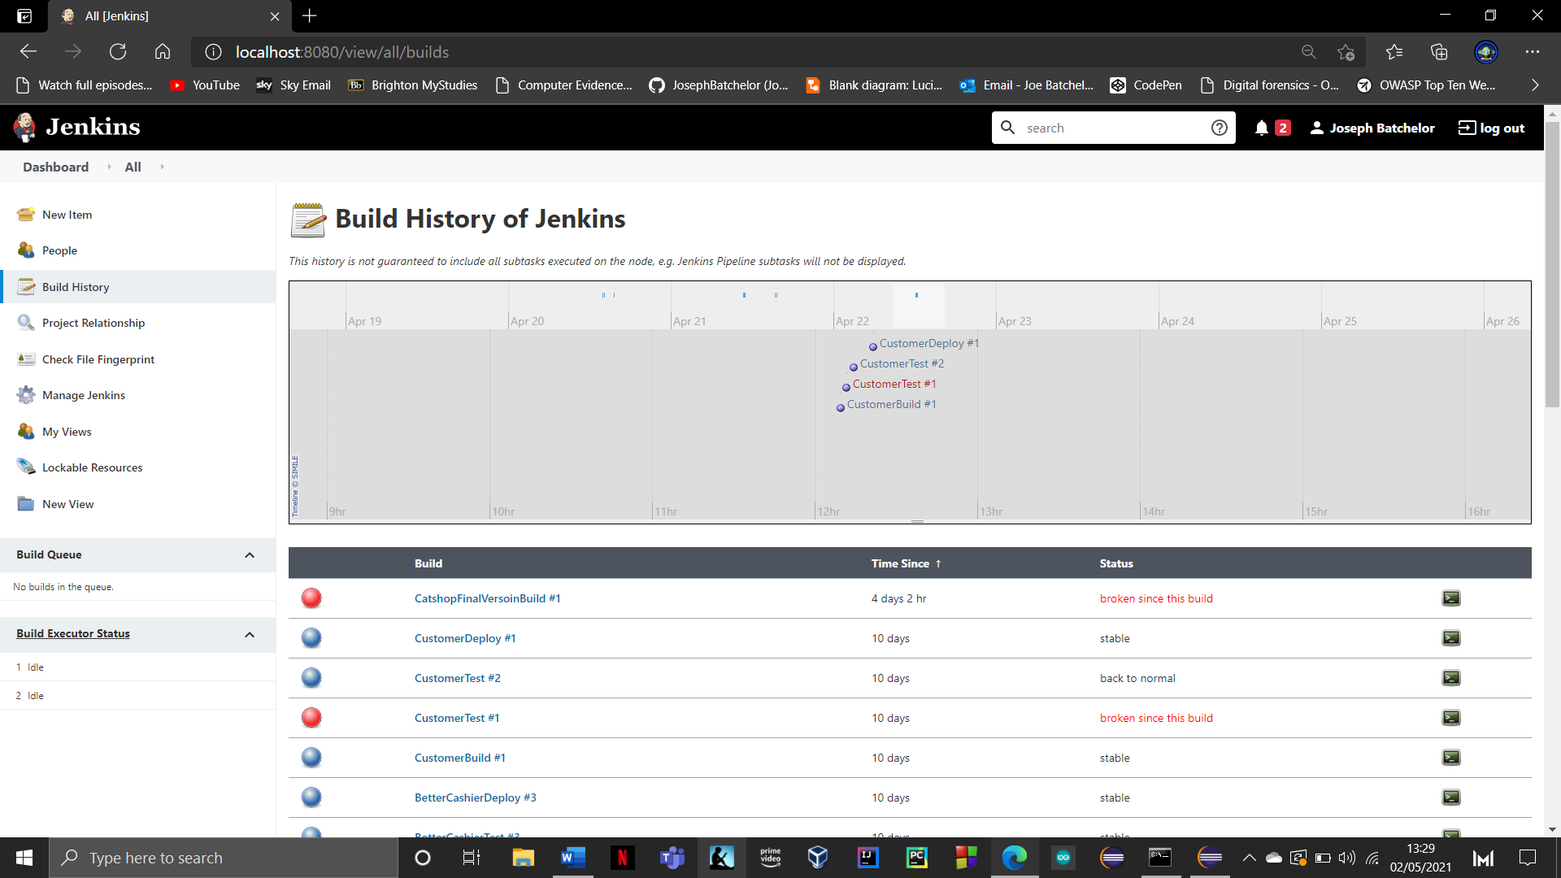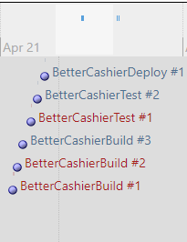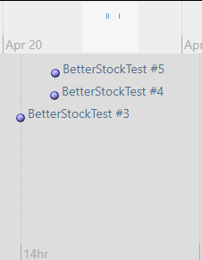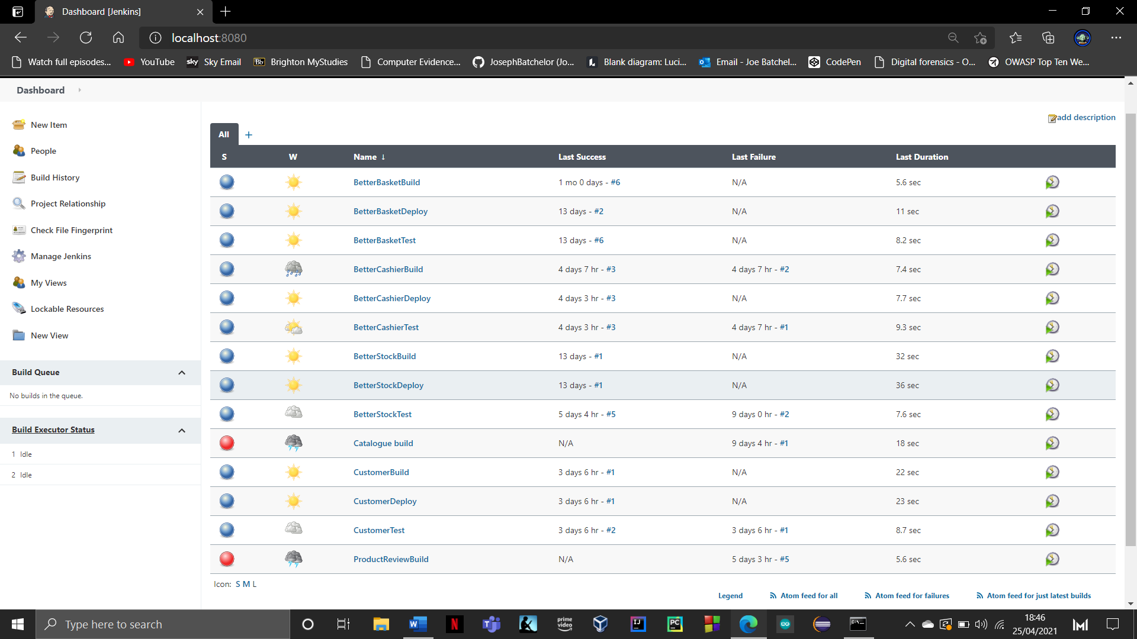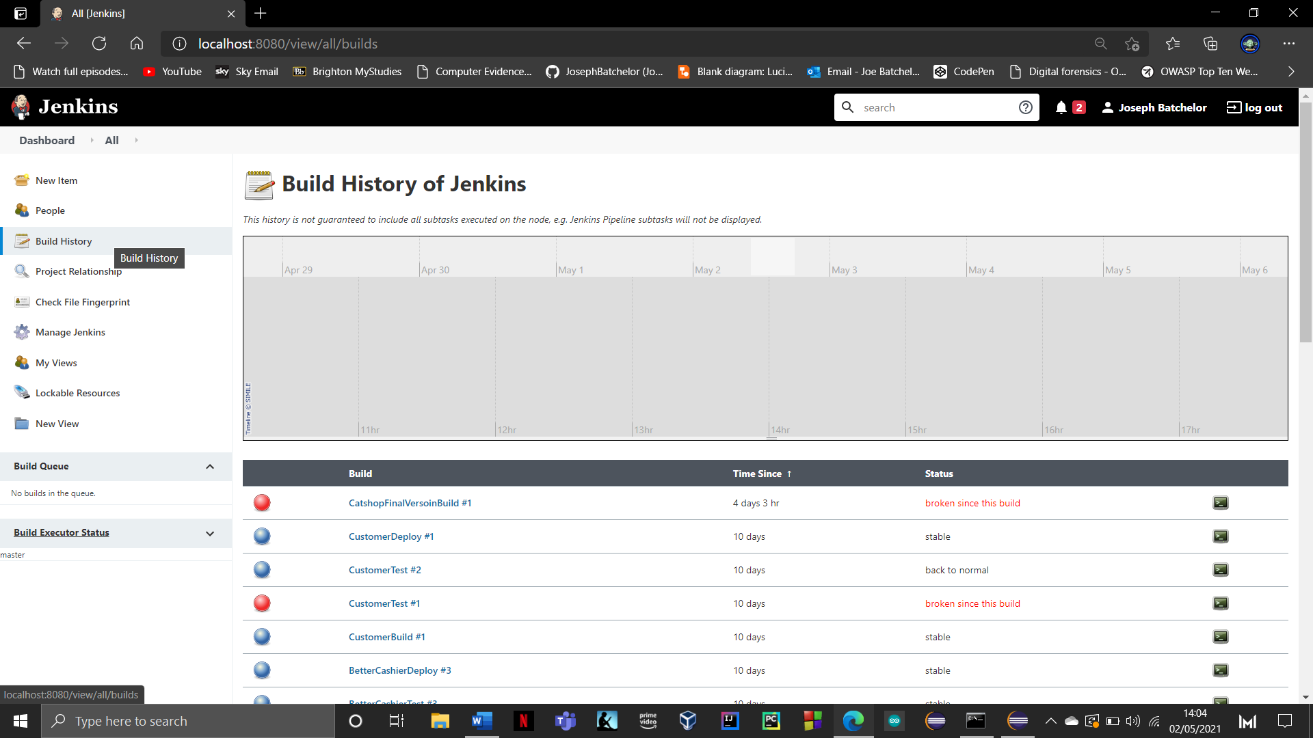

Below you can see the build history for most of my pipelines. This is a useful feature as it records the time and date when built.

All but three developed branches functioned on Jenkins. The new packages introduced such as product review , advertisement and catalogue unfortunately did not work as I kept getting a persistent error which was not present within my code. Each of the branch’s builds kept presenting these warnings which when inspected in the code itself was fine as the imports were in main.

**Javadoc**

Javadoc is a tool which comes installed with your JDK. It is used for generating Java code documentation in HTML format from Java source code. This section is a tutorial on how to use Javadoc on eclipse as well as an example of a generated document on a client.

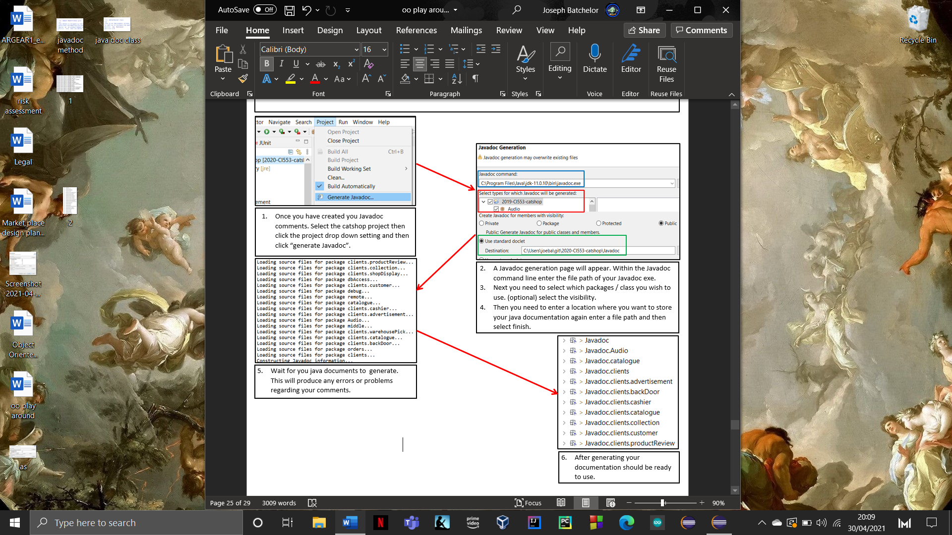**Generating a Javadoc tutorial**

**Javadoc overview**

This is an overview of the generated Javadoc for the catshop project. This briefly shows the packages , class, and hierarchy of the project.

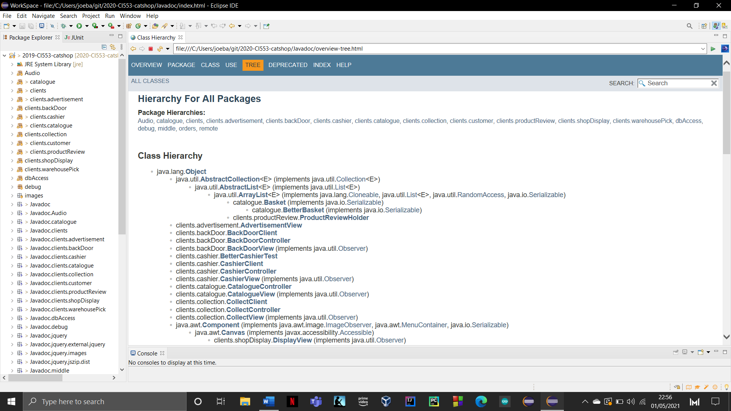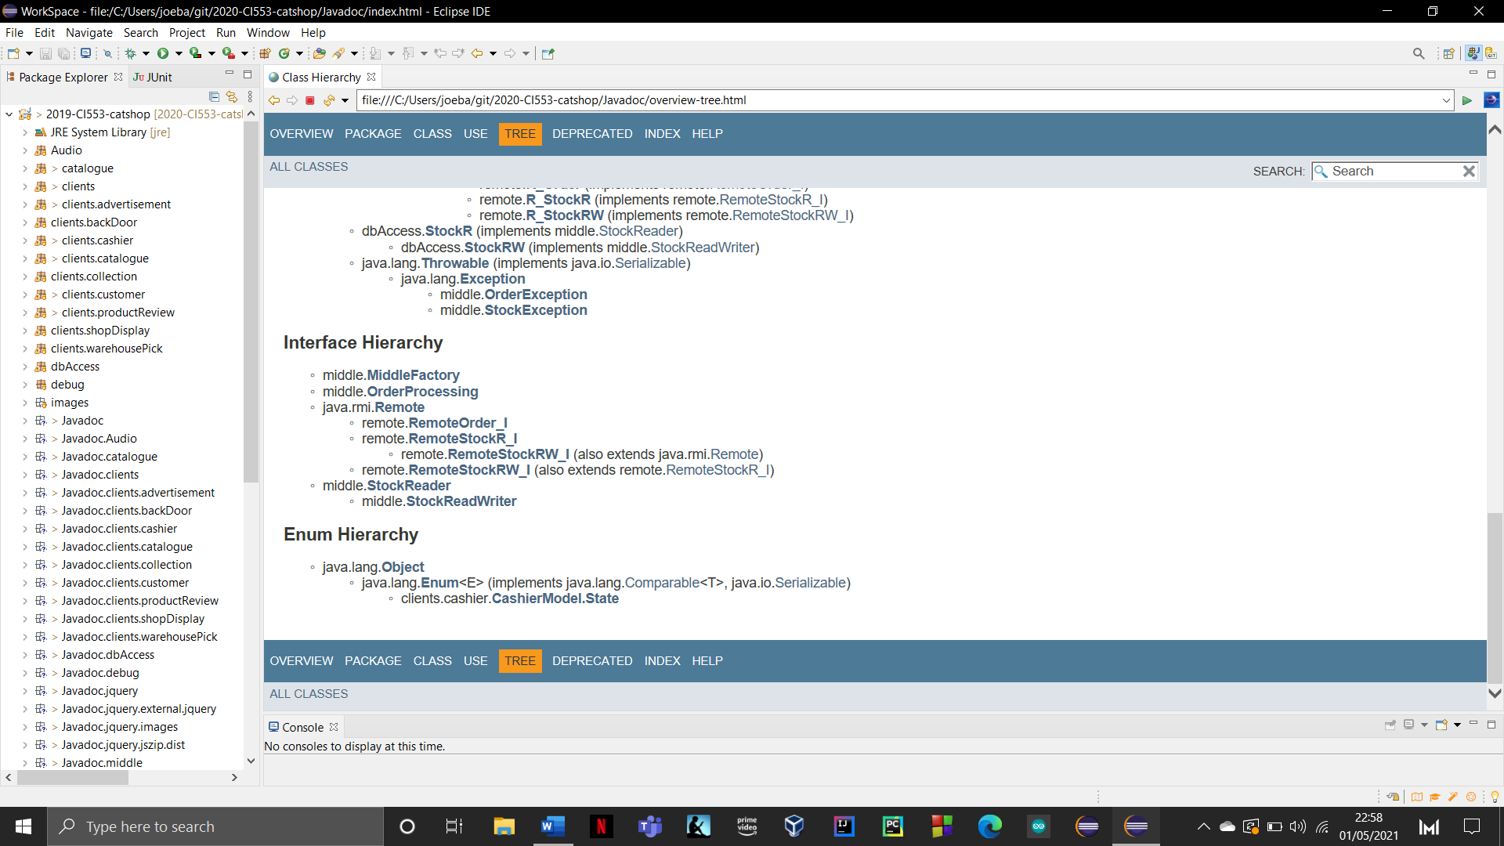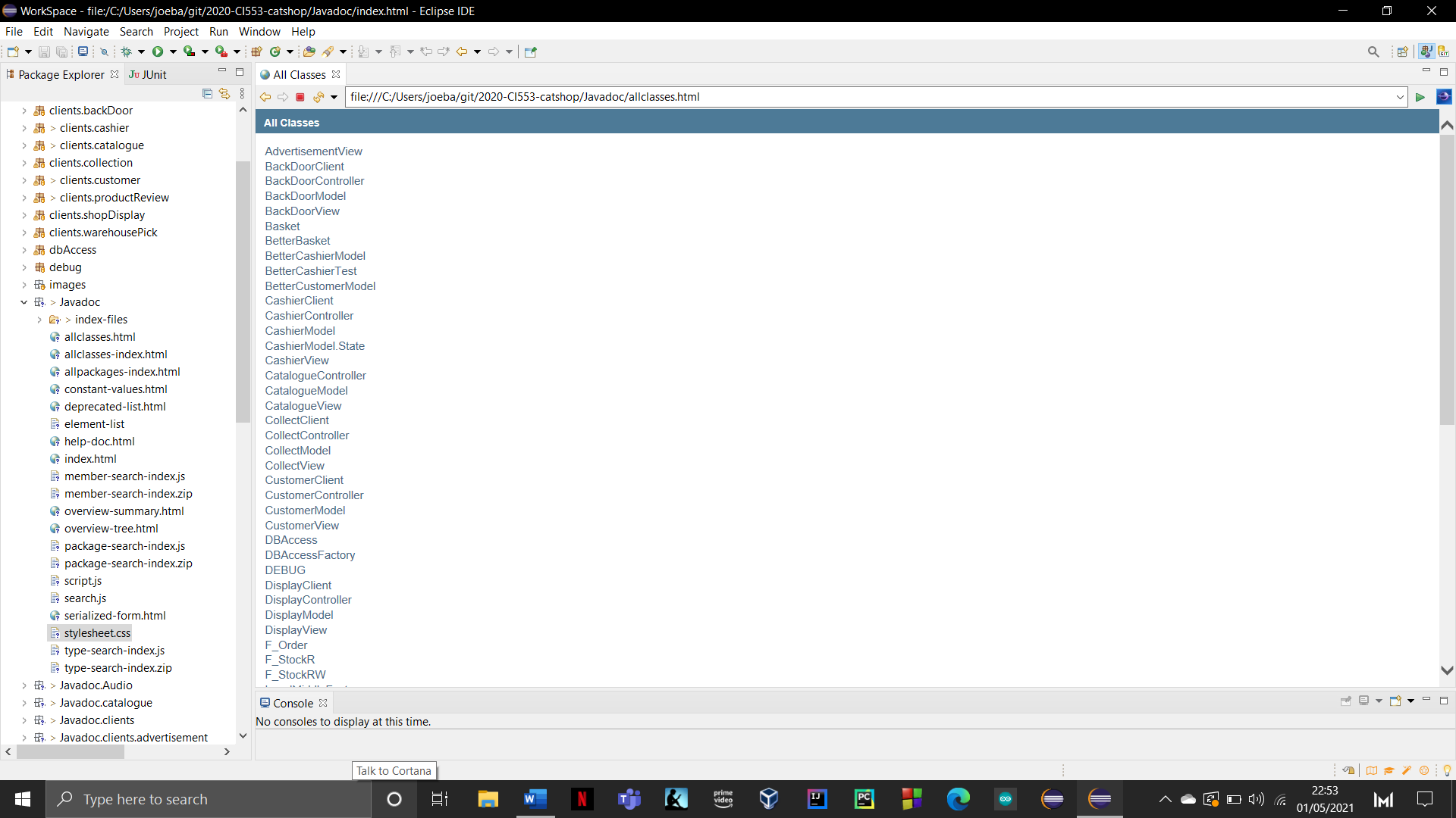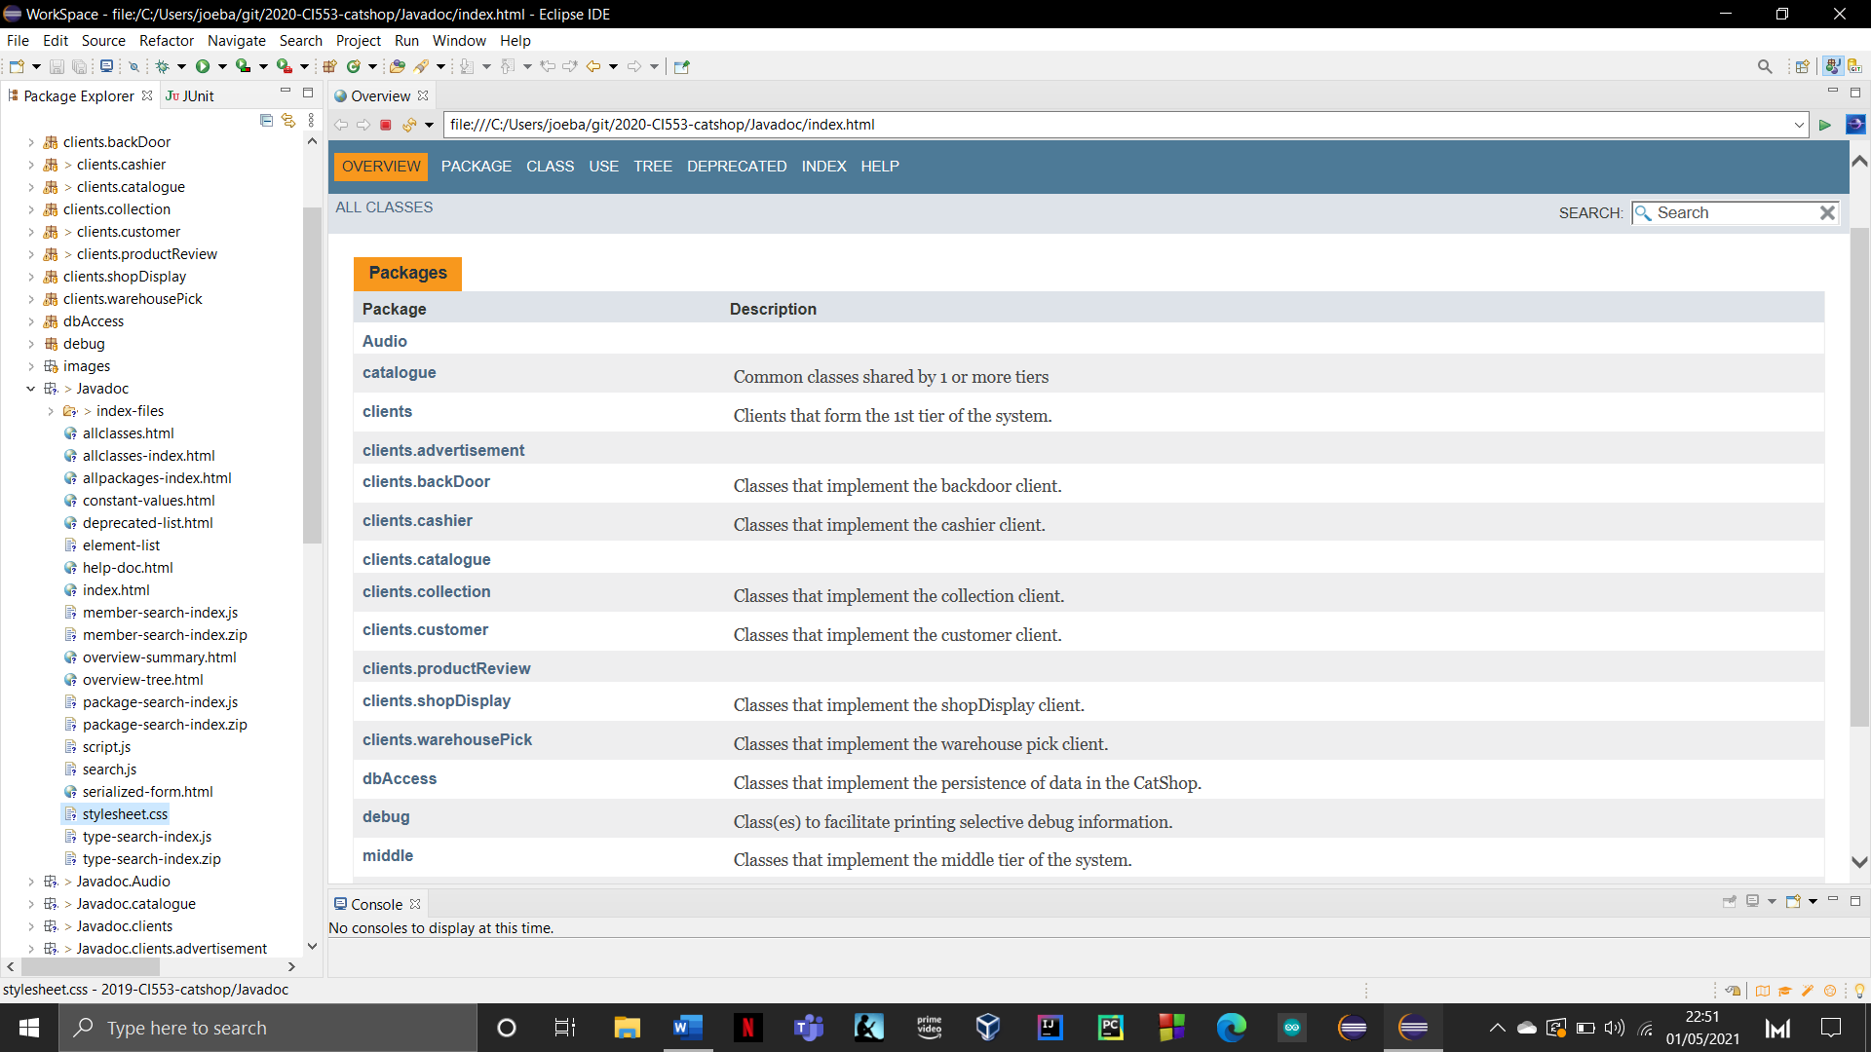

The tree section displays the hierarchy of packages, class, interfaces and Enums. This provides a universal superclass called Object that is defined to be the root of the entire class hierarchy. This will break down the entire project from object.

Clicking all class will display every class created within the project for quick access.

This overview sections lists all the packages created within the catshop project. This also provides a brief description regarding the overall function of the package. Clicking into one of these packages will show you the class within.

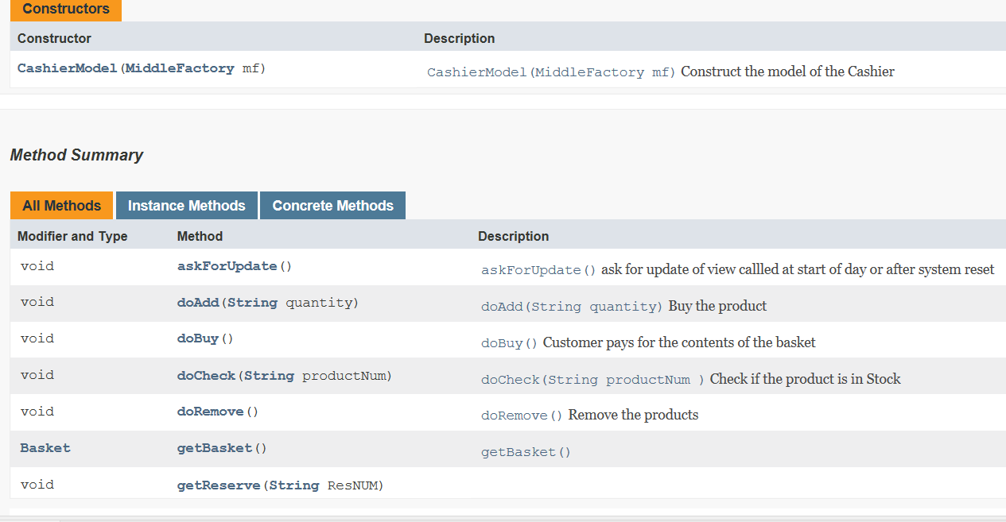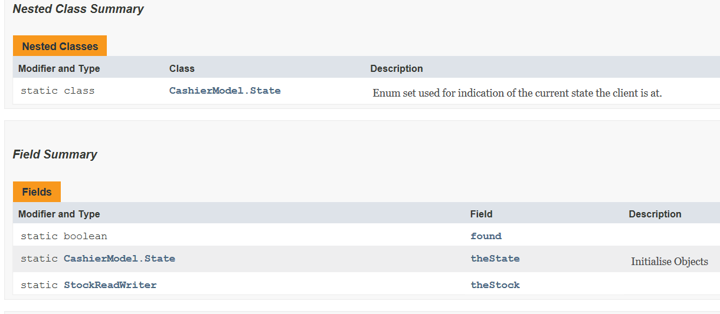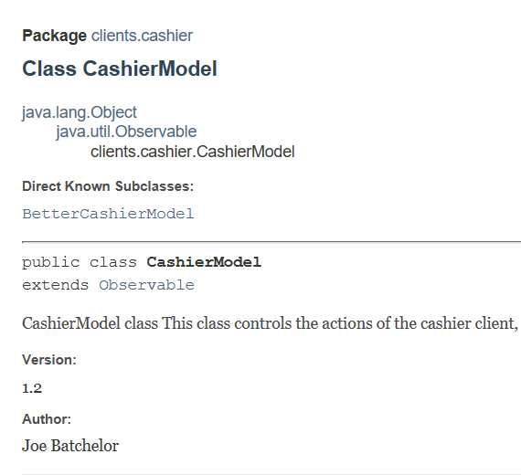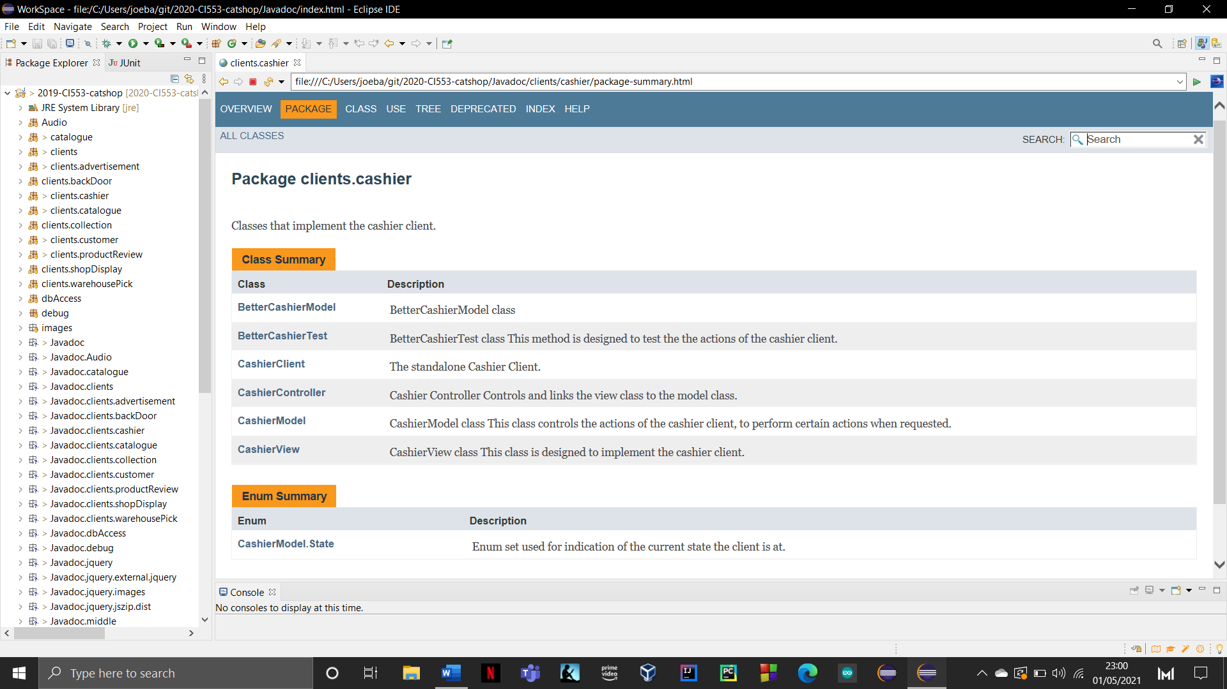**Cashier client Javadoc example**

To see the entire generated java doc with all the classes and packages can be found at [JosephBatchelor/2020-CI553-catshop: CatShop system for 2020-CI553 cohort (github.com)](https://github.com/JosephBatchelor/2020-CI553-catshop/tree/master). it will the top folder this can be accessed which contains all the html and files to display it. Simply download the folder and open the “allpackages-index.html” this will provide all the information.

The method summary displays the method name and its parameters it takes. As well as the modifier & type it has. This gives brief description of what the method does with the use of java doc comments.

This section is to show how catshop breakdowns each class from their package. In this example I will be using catshop.

Within the class section it will show a field summery which is different a combinations of varibles and objects being created. It will state its name and a description of what is does.

Additionally, with the use of comments I was able to add an author and the version this class was at.

When selecting a class, you will be presented with a main area which describes the class and relevant details.

When client cashier has been selected from the package overview, this will display a class summary which is just an over look at the classes created within the cashier package. This will also provide a brief description regarding this function.

This level also provides and overview over the Enums used within the package.

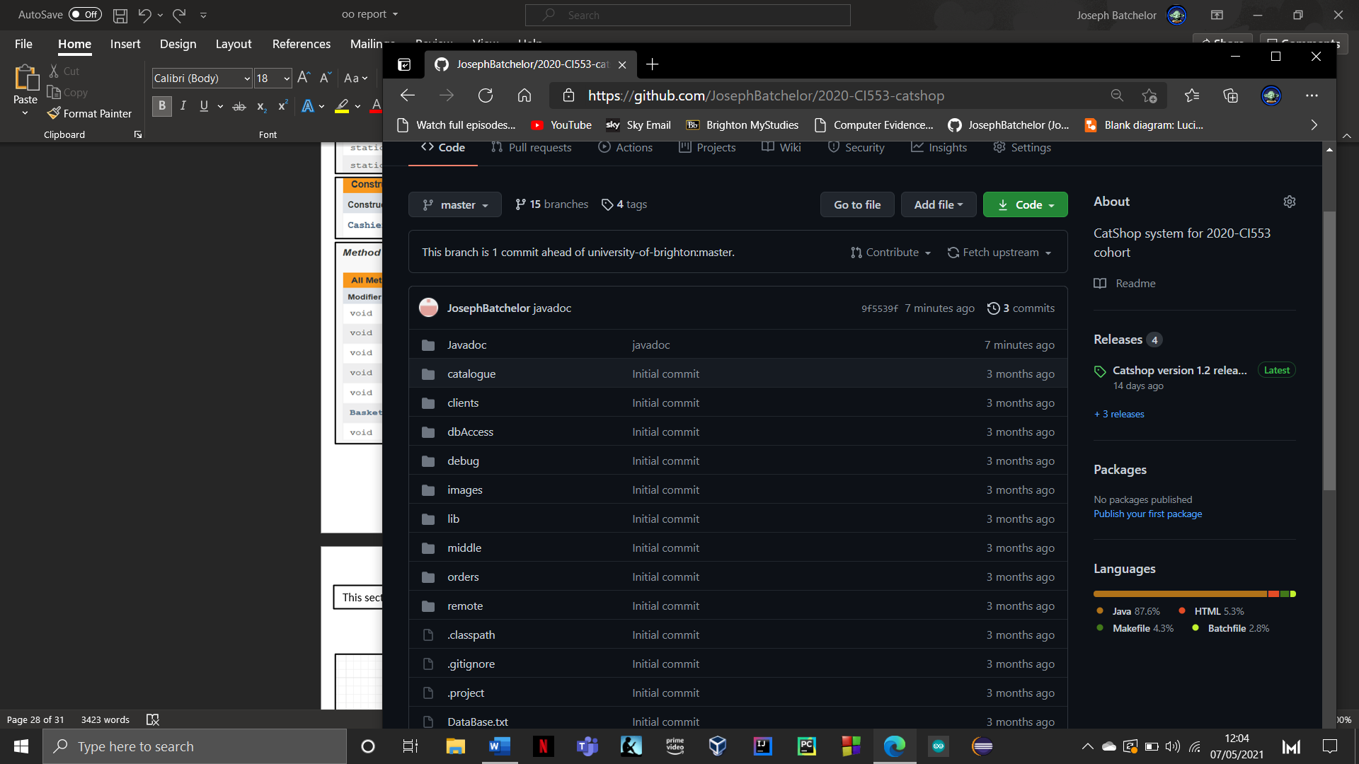

**Catshop final UML functionality diagrams**

This section simply displays the functionality of each client in its final form with the use of UML user & sequence diagrams.

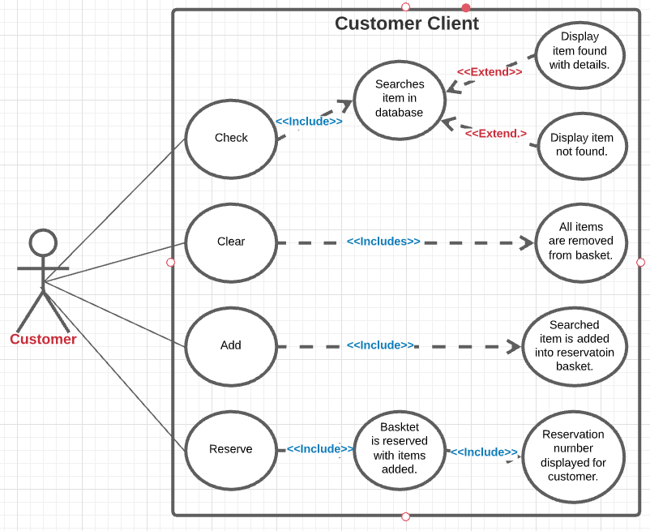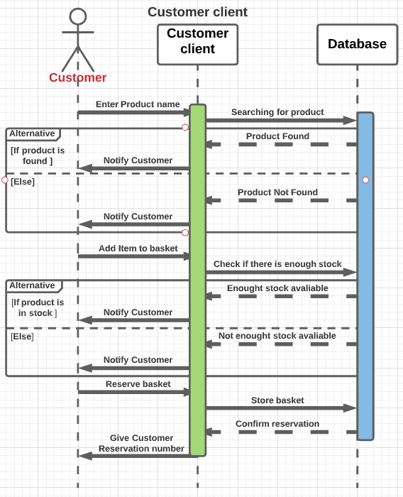

**Customer Client**

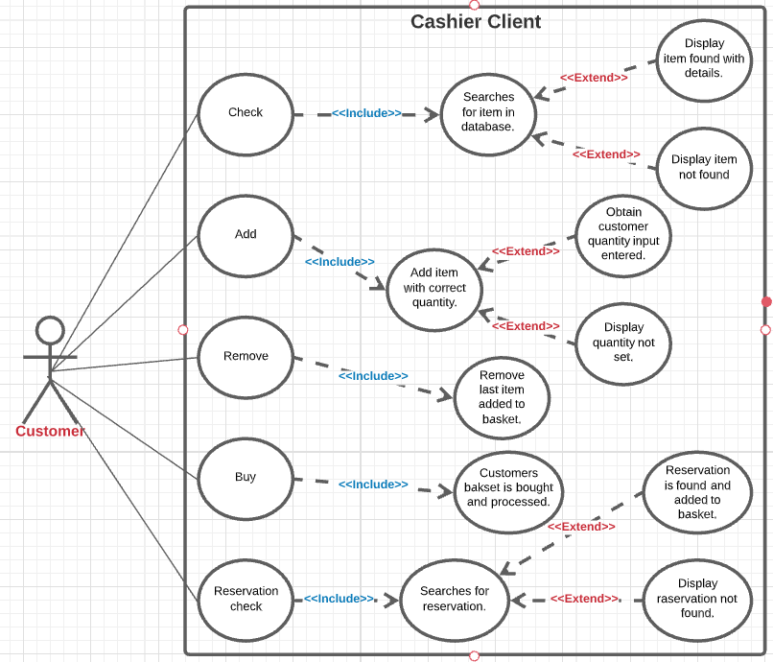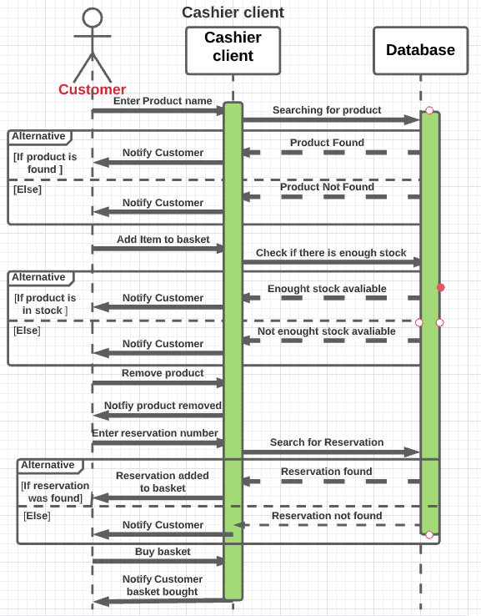

**Cashier Client**

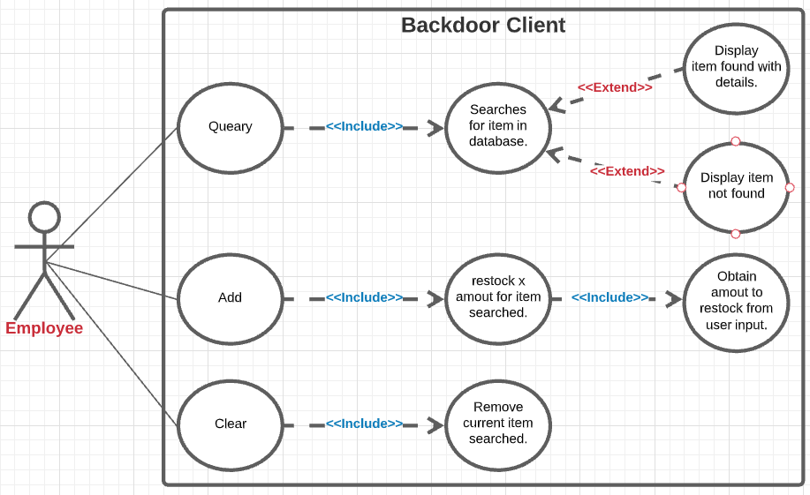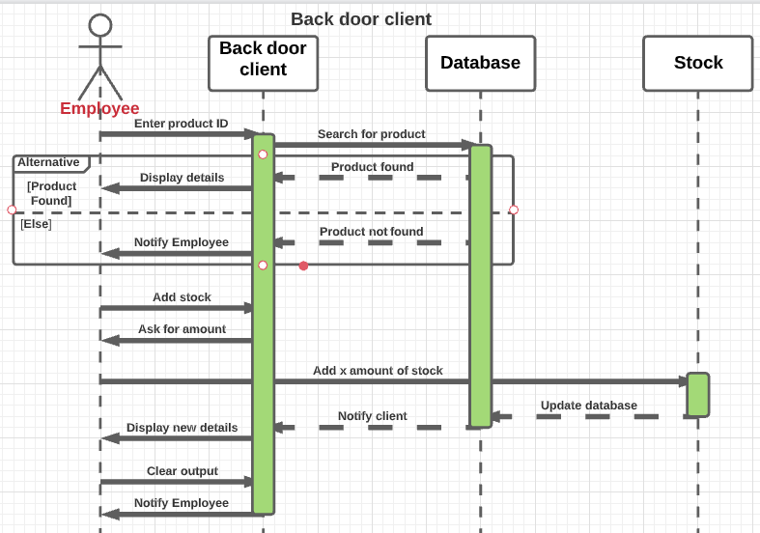

**Backdoor Client**

**Product review Client**

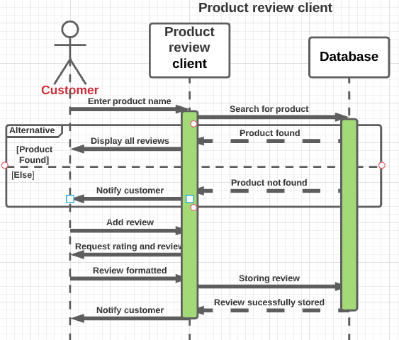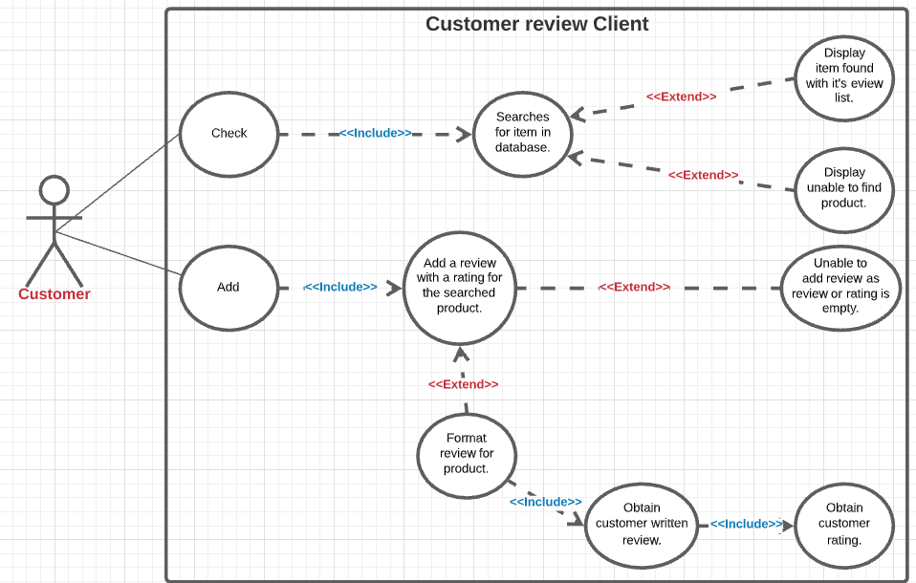

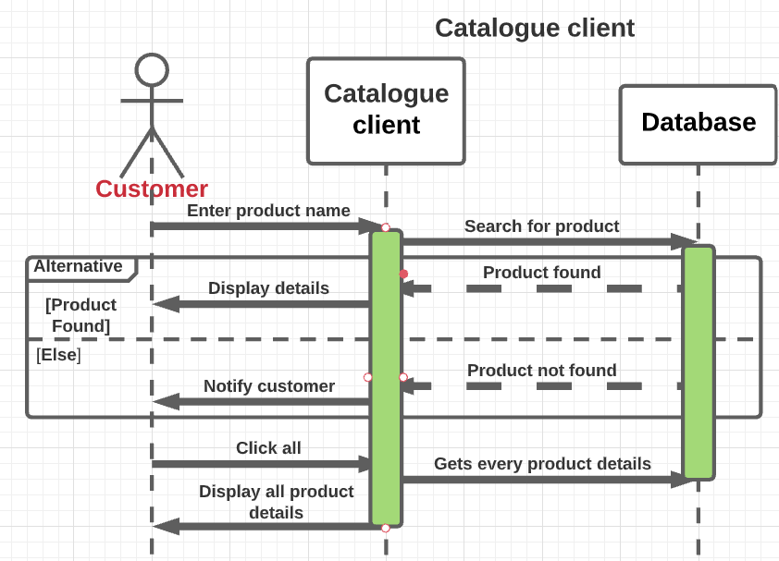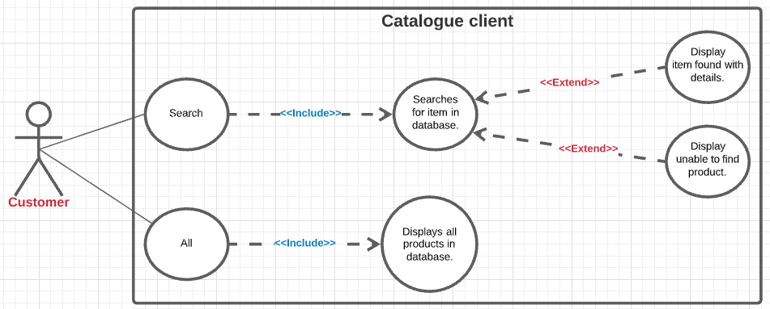

**Catalogue Client**

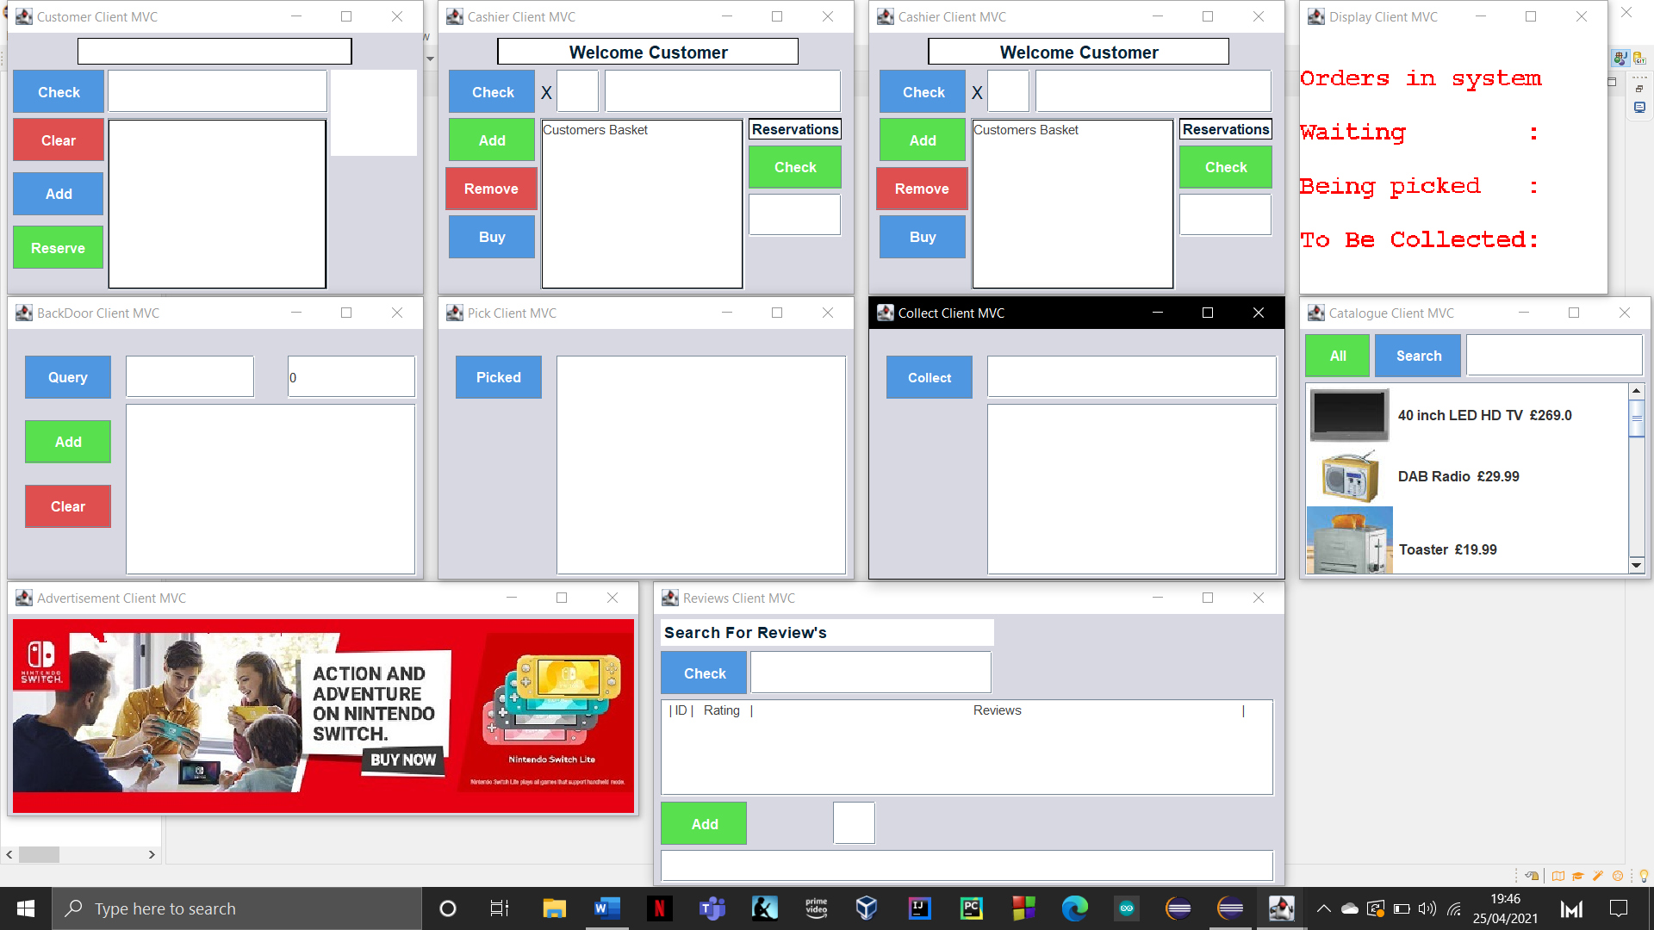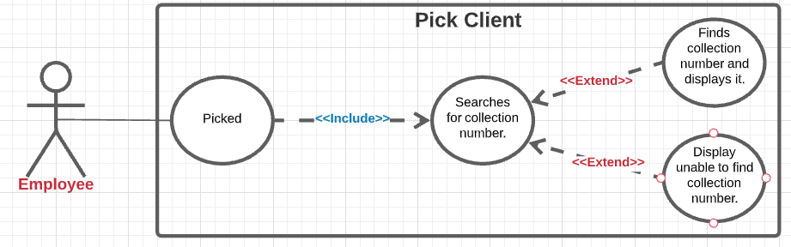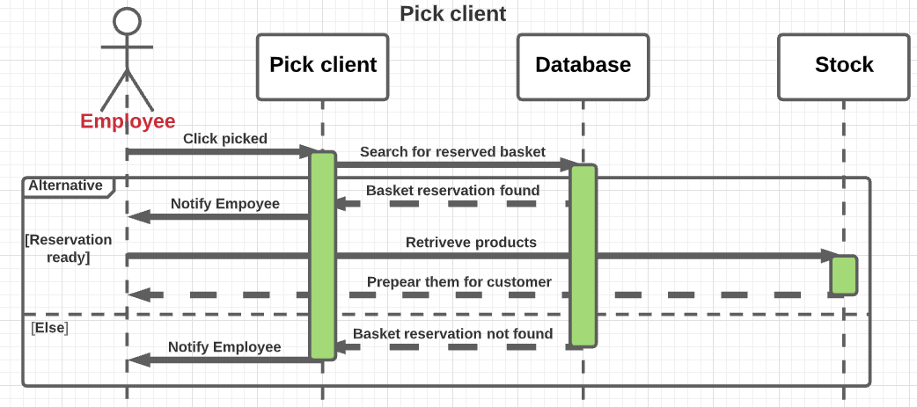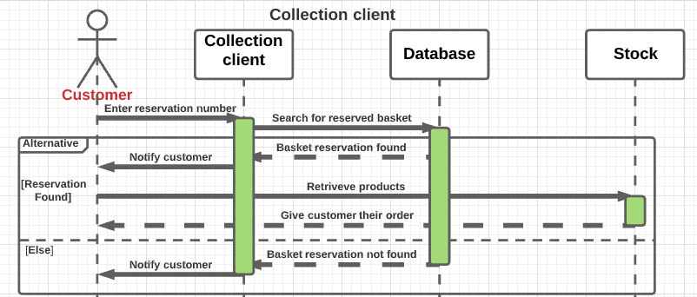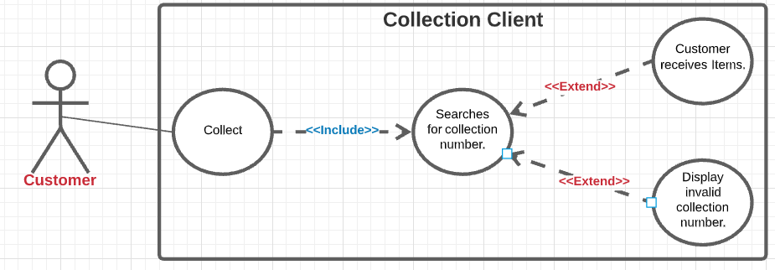

**Final display of a fully functional catshop**

**Pick Client**

**Collection Client**